**Egyptian E-Learning University**

Faculty of Computers & Information Technology

**Development of a Skin Disease Detection System Using Neural Network**

**By**

|  |  |
| --- | --- |
| **Marina Emad Mored Habeb** | **2101013** |
| **Mera Refat Gaballah** | **2101090** |
| **Martina William Takawy** | **2101031** |
| **Sara Raafat Rasmy** | **2101569** |
| **Nardeen Maged Alfons** | **2101354** |
| **Mariam Sameh Fawzi** | **2100979** |
| **Marina Ashraf Farouk** | **2101014** |

Supervised by

**Dr. Amany Magdy Mohamed**

lecturer in Computer and Information Technology Egyptian E-Learning University

Assistant

**Eng.Mohamed Mostafa Saad**

Teacher Assistant in Computer and Information Technology Egyptian E-Learning University

Sohag-2025

# **Abstract**

Skin diseases are among the most common health issues worldwide, affecting millions of people of different ages. These conditions can range from mild irritations to severe and chronic infections that significantly impact a person's quality of life. Therefore, early and accurate diagnosis is crucial to prevent complications, reduce the burden on healthcare systems, and ensure timely and effective treatment. This graduation project focuses on developing an intelligent system capable of automatically detecting and classifying different types of skin diseases using advanced deep learning techniques. The system is trained on a comprehensive and well-organized dataset of labeled skin images that include examples of common dermatological conditions. Through this training process, the model learns to extract visual features and patterns that help distinguish between various diseases. The core technology used in this project is convolutional neural network (CNNs), which have proven highly effective in image analysis and medical diagnostics. The primary goal is to assist dermatologists in making faster and more accurate diagnoses, while also offering patients a preliminary self-assessment tool.This system has the potential to significantly improve access to dermatological care, especially in rural or underserved areas that lack access to specialists, thereby contributing to better overall public health outcomes.

# **Acknowledgments**

First and foremost, praises and thanks to God, the Almighty, for his blessing throughout our years in college and our graduation project to complete this stage of our life successfully.

We have made efforts in this project. However, it would not have been possible without the kind support and help of many individuals and organizations. I would like to extend my sincere thanks to all of them.

Thanks to Egyptian E-Learning University Sohag center for helping us to reach this level of awareness.

We would like to express our deep and sincere gratitude to our project supervisor **DR. Amany Magdy Mohamed** for giving us the opportunity to lead us and providing invaluable guidance throughout this project. It was a great privilege and honor to work and study under his guidance. We are extremely grateful for what he has offered us.

We are especially indebted to say many thanks to **Eng. Mohamed Mostafa Saad** for guidance and constant supervision as well as for his patience, friendship, empathy, and great sense of humor. His dynamism, vision, sincerity and motivation have deeply inspired us.

Finally, we would like to express our gratitude to everyone who helped us during the graduation project.

**Contents**

Abstract 2

Acknowledgments 3

Introduction 12

1.1 General 13

1.2 Background 14

1.3 Motivation 15

1.4 Problem Statement 16

1.6 Objectives 17

1.6.1 Main Objective 17

1.6.2 Specific Objectives 17

**Related Work 18**

2.1Related Work 19

2.2 Limitation 20

2.3 Summary 20

**Proposed system 21**

3.1 Approach used to solve the problem 22

3.1.1 CNN (Convolutional Neural Network) 22

3. Activation Function (ReLU) 22

4. Pooling Layer 23

5. Flatten Layer 23

3.2 System architecture 24

3.2.1 Flowchart 24

3.2.2 Use Case 25

3.2.3 ER diagrams 25

3.3 Algorithms used 26

3.3.1 EfficientNetB0 26

3.3.2 ResNet50 27

3.3.3 VGG16 28

3.3.4 InceptionV3 29

3.3.5 MobileNetV2 30

3.6 Frameworks Used 31

3.6.1 TensorFlow 31

3.6.2 Flask 31

3.6.3 Flutter 31

3.6.4 Firebase 31

**Implementation 32**

4.1 Technologies, tools, and programming languages used. 33

4.2 Key components/modules of the system. 33

4.2.5 Splash Screen Component 34

4.2.6 Authentication Component 34

4.2.7 User Interface Component 34

4.2.8 Disease Information Component 34

4.2.9 Image Upload & Diagnosis Component 35

4.2.10 Hospitals Locator Component 35

4.2.11 Settings Component 35

4.2.12 Backend Component 35

4.3 Challenges faced and how they were resolved. 36

5.1 Testing strategies 39

5.1.1 Unit Testing 39

5.1.2 Integration Testing 39

5.1.3 User Testing 39

5.2 Performance metrics 40

5.3 Comparison with existing solutions 40

**Results & Discussion 41**

6.1 Introduction 42

6.2 Summary of Findings 42

6.2.1 AI Model Results: 42

6.2.2 Flutter App Results: 43

6.3 Interpretation of Results (Did the project meet its objectives?) 43

6.4 Limitations of the proposed solution 43

**Conclusion & Future Work 45**

7.1Conclusion 46

7.2 Future Work: 45

**References 48**

**Appendices 51**

8.1 Introduction to the AI Model. 52

8.1.1 Explain Dataset 52

8.2 Introduction to Flutter 61

8.2.1 Splash Screen 61

8.2.2 Home Screen(After Splash Screen) 63

8.2.3 Login Screen 65

8.2.4 The Diseases Screen 73

8.2.5 Disease Detail Screen 77

8.2.6 Image Upload Screen 80

8.2.7 Loading Screen 83

8.2.8 Diagnosis Result Screen 86

8.2.9 Select Governorate Screen 89

8.2.10 Hospitals Screen 91

8.2.11 Menu Drawer 93

8.2.12 Translation Integration 95

8.2.13 Theme Support 96

8.2.14 Flask Backend 97

8.2.15 Firebase 99

**List of Figures:**

Figure 3.1 : CNN Architecture 24

Figure 3.2 : Flowchart 24

Figure 3.3 : Use Case 25

Figure 3.4 :ER diagrams 25

Figure 3.5 :EfficientNetB0 model Architecture 26

Figure 3.6 : ResNet50 model Architecture 27

Figure 3.7 : VGG16 model Architecture 28

Figure 3.8 : InceptionV3 model Architecture 29

Figure 3.9: MobileNetV2 model Architecture 30

Figure 3.10 : Accuracy of model 40

Figure 8.1 : Sample of Dataset 53

Figure 8.2 : Data Augmentation 54

Figure 8.3 : Grid Search 55

Figure 8.4 : Best Parameters of Grid Search 55

Figure 8.5 : Build The Model using EfficientNetB0 56

Figure 8.6 : Training Model 56

Figure 8.7 : Evaluating Model 56

Figure 8.8 : Final Performance 57

Figure 8.9 : Visualizing Training Performance 57

Figure 8.10 : Prediction on Test Set 58

Figure 8.11 :Generate Prediction 58

Figure 8.12 : calculate Evaluation Metrics 59

Figure 8.13 : code of Matric Results & Confusion Matrix 59

Figure 8.14 : Final Evaluation Metrics on Validation Set 59

Figure 8.15 :Confusion Matrix Visualization 60

Figure 8.16 : Splash Screen 61

Figure 8.17 : Code Splash Screen P1 62

Figure 8.18 : Code Splash Screen P2…………………………………...……62

Figure 8.19 : Home Screen……………………………………………………63

Figure 8.20 : Code Home Screen P1 63

Figure 8.21 : Code Home Screen P2 64

Figure 8.22 : Code Home Screen P3 64

Figure 8.23 : Login Screen 65

Figure 8.24 : Code Login Screen P1 65

Figure 8.25 : Code Login Screen P2………………………………………….66

Figure 8.26 : Code Login Screen P3 66

Figure 8.27 : Code Login Screen P4 67

Figure 8.28 : Code Login Screen P5 67

Figure 8.29 : Sign Up Screen 68

Figure 8.30 : Code Sign Up Screen P1 69

Figure 8.31 : Code Sign Up Screen P2 69

Figure 8.32 : Code Sign Up Screen P3 70

Figure 8.33 : Code Sign Up Screen P4 70

Figure 8.34 : Code Sign Up Screen P5 71

Figure 8.35 : Code Sign Up Screen P6 71

Figure 8.36 : Code Sign Up Screen P7 72

Figure 8.37 : Code Sign Up Screen P8 72

Figure 8.38 :The Diseases Screen 73

Figure 8.39 : Code Diseases Screen P1 74

Figure 8.40 : Code Diseases Screen P2 74

Figure 8.41 : Code Diseases Screen P3 75

Figure 8.42 : Code Diseases Screen P4 75

Figure 8.43 : Code Diseases Screen P5 76

Figure 8.44 : Code Diseases Screen P6 76

Figure 8.45 : Code Diseases Screen P7 77

Figure 8.46 : Disease Detail Screen 77

Figure 8.46 : Code DiseasePageTemplate p1 78

Figure 8.47 : Code DiseasePageTemplate p2 78

Figure 8.48 : Code DiseasePageTemplate p3 79

Figure 8.49 : Code DiseasePageTemplate p4 79

Figure 8.50 : Code Disease Detail Screen 80

Figure 8.51 : Image Upload Screen 80

Figure 8.52 : Code Image Upload Screen p1 81

Figure 8.53 : Code Image Upload Screen p2 81

Figure 8.54 : Code Image Upload Screen p3 82

Figure 8.55 : Code Image Upload Screen p4 82

Figure 8.56 : Code Image Upload Screen p5 83

Figure 8.57 : Loading Screen 83

Figure 8.58 : Code Loading Screen p1 84

Figure 8.59 : Code Loading Screen p2 84

Figure 8.60 : Code Loading Screen p3 85

Figure 8.61 : Diagnosis Result Screen 86

Figure 8.62 : Code Diagnosis Result Screen p1 87

Figure 8.63 : Code Diagnosis Result Screen p2 87

Figure 8.64 : Code Diagnosis Result Screen p3 88

Figure 8.65 : Select Governorate Screen 89

Figure 8.65 : Code Select Governorate p1 90

Figure 8.66 : Code Select Governorate p2 90

Figure 8.67 : Hospitals Screen 91

Figure 8.67 : Code Hospitals Screen p1 92

Figure 8.68 : Code Hospitals Screen p2 92

Figure 8.69 : Menu Drawer 93

Figure 8.70 : Code Menu Drawer p1 93

Figure 8.71 : Code Menu Drawer p2 94

Figure 8.72 : Code Menu Drawer p3 94

Figure 8.73 : Translation 95

Figure 8.74 : Code Translation 96

Figure 8.75 : Theme Support 97

Figure 8.76 : Code Flask p1 98

Figure 8.77 : Code Flask p2 98

Figure 8.78 : Firebase 1 99

Figure 8.79 : Firebase 2 100

# List of Tables:

Table 2.1: Related Work………...………………………………………….19

Table 8.1 :Dataset…..……………………………………………………….53

# 

# 

# **List of Acronyms/Abbreviations:**

(AI) Artificial Intelligence

(CNN)Convolutional Neural Networks

(SVM) Support Vector Machine

(KNN) K-Nearest Neighbor

(ReLU ) Rectified Linear Unit

(VGG16) Visual Geometry Group 16

Chapter 1

# **Introduction**

## **1.1 General**

Skin diseases are among the most widespread health problems affecting people across the globe. They vary greatly in type and severity, ranging from mild conditions such as acne and eczema to more serious diseases like melanoma and psoriasis. Due to the visible nature of skin disorders, they often cause not only physical discomfort but also psychological stress and social anxiety for affected individuals. Early detection and appropriate intervention are therefore essential to prevent complications and improve patients' quality of life.

However, diagnosing skin diseases can be a complex task, even for experienced dermatologists. This complexity arises from the fact that many skin conditions share similar visual symptoms, such as rashes, discoloration, or lesions, which can make accurate diagnosis challenging without professional expertise and tools.

To address this challenge, this project aims to develop an intelligent system based on CNNs that can automatically detect and classify various skin diseases from image data. By leveraging the power of deep learning and computer vision, the proposed system can assist in identifying potential skin conditions with high accuracy.

The goal is not to replace medical professionals but to provide an initial assessment tool that offers preventive advice and encourages users to seek medical attention promptly. This can be especially beneficial in areas with limited access to dermatologists, helping bridge the gap between early detection and proper treatment . [1]

## **1.2 Background**

Skin diseases are among the most common health issues worldwide, affecting people of all ages and backgrounds. These conditions include acne, eczema, psoriasis, and other non-cancerous dermatological problems. With the rapid development of Artificial Intelligence (AI), especially deep learning, there has been growing interest in using these technologies to support the diagnosis of skin diseases.

The idea of using computers for dermatological diagnosis began in the late 1990s, when researchers started applying image processing techniques to detect patterns in skin images. However, due to limitations in computational power and the lack of large, labeled datasets, early attempts faced significant challenges.

In recent years, the emergence of powerful deep learning models such as CNNs , along with access to large and well-annotated datasets like ISIC, has enabled significant progress in automated skin disease classification. These models can now identify complex features in medical images and offer accurate diagnostic support.

The main motivation behind developing AI-based tools for skin disease diagnosis is to provide faster, more accessible, and more consistent diagnostic assistance—especially in regions where dermatologists are not readily available. These tools can support general practitioners and improve the early detection and management of skin conditions.

Our project builds on these advancements by developing a system that uses deep learning techniques to classify common skin diseases based on image data. By leveraging the power of AI, we aim to contribute to the field of smart healthcare and offer an efficient, automated solution for dermatological diagnosis. [1]

## **1.3 Motivation**

Dermatological diseases are a significant global health challenge, affecting millions of individuals worldwide. Despite their widespread occurrence, diagnosing these conditions often presents a considerable challenge due to the diverse nature of skin diseases and the overlapping symptoms that many share. As a result, accurate diagnosis frequently requires the expertise of dermatologists and specialized medical equipment. This can create barriers to timely diagnosis and treatment, especially in areas with limited access to healthcare professionals.

The rising prevalence of dermatological conditions, combined with the shortage of dermatologists in many regions, makes it increasingly critical to develop efficient diagnostic tools. This growing demand for more accurate and accessible diagnostic methods is vital not only to improve healthcare delivery but also to reduce the burden on healthcare systems. The ability to diagnose skin diseases early can significantly reduce the risk of complications and lead to more effective treatments, ultimately improving patient outcomes and quality of life.

In recent years, the application of AI and deep learning techniques has shown great promise in transforming the healthcare industry, particularly in the field of medical imaging. AI-driven models, such as CNNs , have the potential to automate the diagnostic process by analyzing medical images with a level of precision and speed that surpasses traditional methods. By leveraging these technologies, it is possible to offer innovative solutions that not only enhance diagnostic accuracy but also make the process more efficient, which is crucial in managing the growing number of dermatological cases.

The use of medical image analysis for dermatological diseases, specifically through deep learning models, offers significant advantages over traditional diagnostic approaches. These AI-based models can process and analyze large datasets of skin images rapidly, leading to quicker and more accurate diagnoses. This not only enhances the overall efficiency of healthcare delivery but also

facilitates early detection of diseases, which is critical for improving patient outcomes. By providing early assessments and preventive advice based on the

analysis of images and data, this system can assist patients in seeking medical attention sooner, thereby reducing the risk of severe health complications.

This project seeks to develop an intelligent model that analyzes and classifies dermatological conditions from skin images, offering a valuable tool for early detection. The system will provide essential preventive advice and guidance, encouraging patients to visit a healthcare professional for further evaluation, ensuring timely and accurate medical intervention.

## **1.4 Problem Statement**

Skin diseases are among the most widespread health conditions, and early diagnosis plays a crucial role in effective treatment. However, many individuals face significant delays in diagnosis, which can lead to the worsening of their condition—especially in cases where skin diseases progress rapidly if left untreated.

One of the major challenges is the general lack of awareness regarding skin conditions, their symptoms, and the preventive measures needed to manage them. This limited understanding often leads to unnecessary anxiety and hesitation in seeking medical attention. Furthermore, people frequently rely on online images for self-diagnosis, which can be misleading due to the visual similarities between different dermatological conditions. Such confusion increases the risk of misdiagnosis or neglect.

Another critical issue is the difficulty in accessing reliable medical services. Many individuals are unaware of nearby hospitals or specialized dermatologists who can provide accurate and timely care for skin-related concerns. This gap in accessibility and awareness further contributes to delayed treatment and poor health outcomes.

Therefore, there is a growing need for an intelligent, accessible system that can assist in the preliminary identification of common skin diseases, raise awareness, and guide users toward appropriate medical resources.

## **1.6 Objectives**

### **1.6.1 Main Objective**

The primary goal of this project is to develop an AI-powered mobile application capable of providing fast, accurate, and accessible diagnosis of common skin diseases through image analysis. The app aims to improve early detection, increase user awareness, and facilitate access to specialized medical care.

### **1.6.2 Specific Objectives**

* To design and implement an image processing module that uses deep learning techniques for accurate classification of skin diseases.
* To create a reliable information database within the app that educates users about various skin conditions, preventive measures, and care guidelines.
* To integrate an AI-driven diagnostic system that provides instant feedback and recommendations based on analyzed images.
* To develop a location-based service feature that helps users find nearby hospitals and specialized dermatology clinics for professional medical assistance.
* To ensure the app has a user-friendly interface to encourage widespread adoption and ease of use for individuals with varying levels of technical expertise.

Chapter 2

# **Related Work**

## **2.1Related Work**

|  |  |  |  |
| --- | --- | --- | --- |
| **paper** | **Published Date** | **Author** | **Algorithms** |
| Skin Disease Detection using Image Processing and Machine Learning | May17,2023 | SamalJahnavi, Nallamilli Gayatri, Thota Sravani.Publication, ...elt. | Naive Bayes ( 97.5%) accuracy, SVM (90%) and KNN (93.75%) |
| Advance Sy Of Skin Diseases Detection Using Image Processing Methods | in 2022 | Dr.Sandra Paola , Dr. María A ,Dr Jhony A, .....elt . | K-Nearest Neighbor (KNN) (91.2%) with Symlet Analysis, and (SVM) lower accuracy |
| A Method of Skin Disease Detection Using Image Processing and Machine Learning | in 2019 | Nawal Soliman ALKolifi ALEnezi . | Utilizes AlexNet (pretrained CNN) for feature extraction and Support Vector Machine (SVM) achieving (100%) accuracy |

Table 2.1: Related Work

## **2.2 Limitation**

In previous studies related to dermatological disease classification, it was observed that the accuracy rates were not as high as they could have been.

Additionally, most of these studies focused on classifying only a limited number of diseases, which restricted the model's practical application. Expanding the scope to include a wider range of skin diseases would make the model more robust and versatile, addressing a critical gap in the existing research.

## **2.3 Summary**

Recent studies on skin disease detection using image processing and machine learning have explored various algorithms to enhance classification accuracy. For instance, Naive Bayes, SVM, and KNN were applied in one study, achieving accuracies of 97.5%, 90%, and 93.75%, respectively. Another approach utilized KNN with Symlet analysis and SVM, resulting in a 91.2% accuracy, while a deep learning-based method employed AlexNet for feature extraction and SVM for classification, reporting 100% accuracy. However, these studies faced notable limitations: many did not achieve consistently high accuracy across different cases, and most focused on a narrow set of diseases. This limited the models' generalizability and practical use. Expanding future models to cover a broader range of skin conditions would improve robustness and increase their real-world effectiveness. [1] [2] [3]

Chapter 3

# **Proposed system**

## **3.1 Approach used to solve the problem**

### **3.1.1 CNN (Convolutional Neural Network)**

CNNs (CNNs) are a class of deep learning models primarily used for image classification and computer vision tasks. The architecture is inspired by how the human visual system works — learning features gradually from low-level (edges, colors) to high-level (shapes, objects).

**Components of CNN Architecture**

**1. Input Layer**

The input layer of a CNN receives the raw image data, which is usually represented as a 3D matrix of height, width, and channels. The height and width define the image size, while the channels represent colors like red, green, and blue. This format helps the network analyze both spatial and color information.

**2. Convolutional Layer**

In the convolutional layer, small filters or kernels are applied to the input image. These filters, typically sized 3×3 or 5×5, slide over the image performing element-wise multiplication at each position. This process produces a feature map that highlights important patterns in the image, such as edges, corners, and textures, which help to distinguish key details within the image.

### **3. Activation Function (ReLU)**

After each convolutional layer, an activation function is applied to introduce non-linearity into the model. The most commonly used activation function is ReLU (Rectified Linear Unit), which replaces all negative values with zero while keeping positive values unchanged. This process allows the model to learn complex patterns by enabling it to capture non-linear relationships within the data.

### **4. Pooling Layer**

The pooling layer serves to reduce the dimensions of the feature maps generated by the convolutional layers. The most commonly used pooling method is Max Pooling, which works by selecting the maximum value within a specified window of the feature map. This reduction helps decrease computational load and controls overfitting while preserving important features.

### **5. Flatten Layer**

After completing the convolution and pooling operations, the resulting two-dimensional feature maps are flattened into a one-dimensional vector. This flattened vector is then passed into the fully connected (dense) layers, which process the information for final classification or prediction tasks.

**6. Fully Connected (Dense) Layers**

Fully connected (dense) layers function similarly to traditional neural networks. They learn to combine the extracted features from previous layers and make decisions based on them. The final dense layer typically uses a Softmax activation function for multi-class classification tasks, or a Sigmoid activation function for binary classification.

**7. Output Layer**

The output layer produces the final prediction, such as the class of a skin disease. In classification tasks, this layer typically provides a probability distribution over all possible classes, indicating the likelihood of the input belonging to each class. [4]

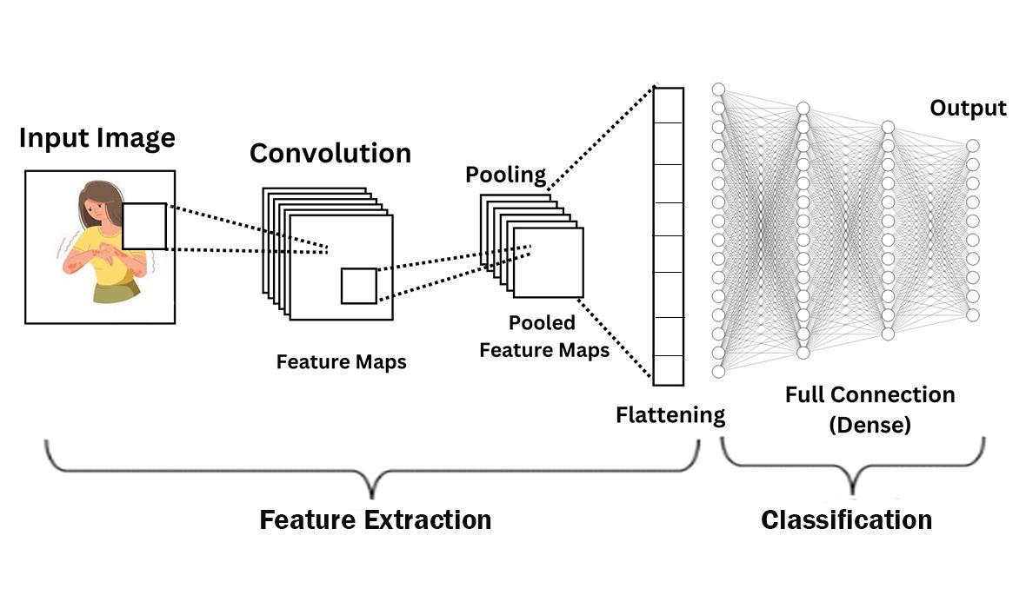

Figure 3.1 : CNN Architecture

## **3.2 System architecture**

### **3.2.1 Flowchart**

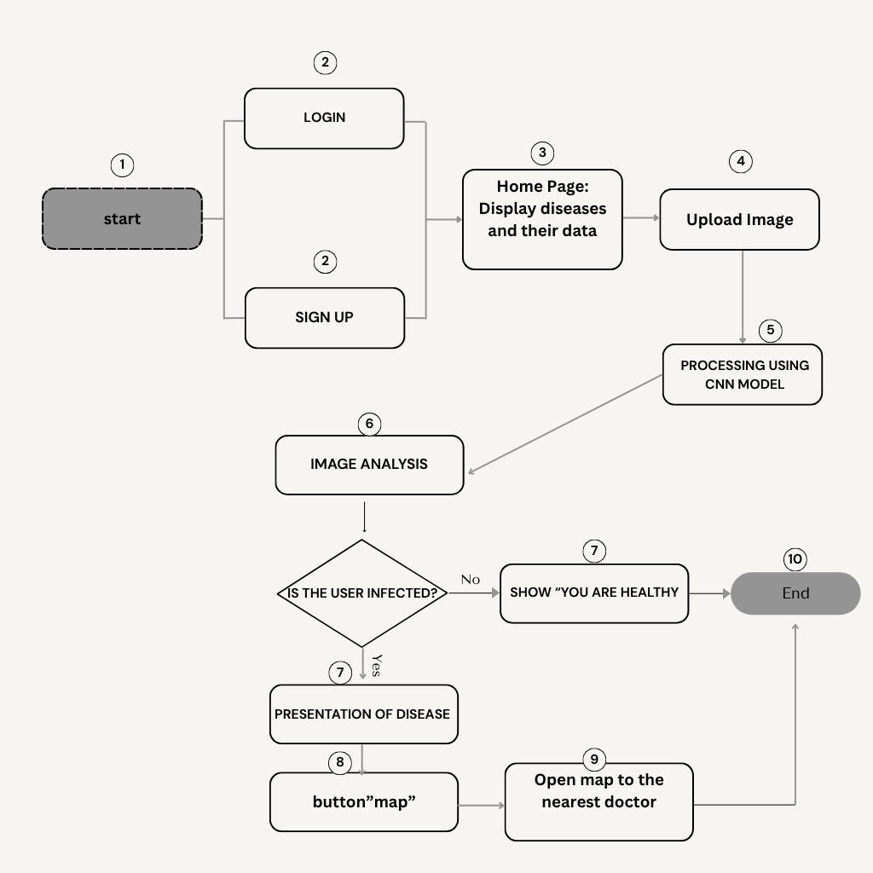Figure 3.2: Flowchart

### **3.2.2 Use Case**

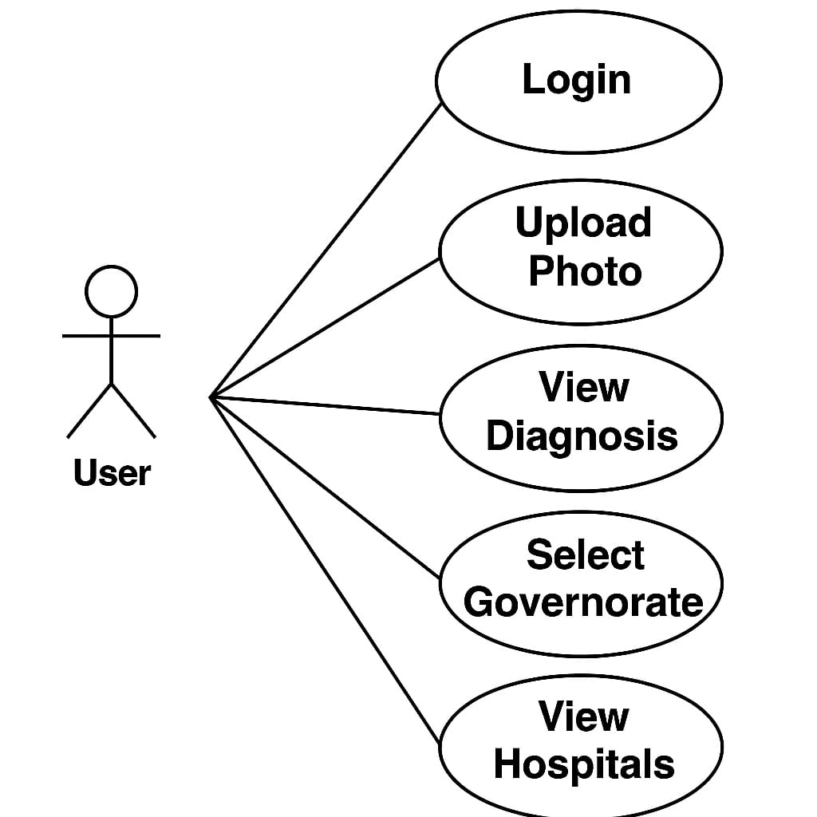Figure 3.3 : Use Case

**3.2.3 ER diagrams**

# 

# Figure 3.4 : ER diagrams

## **3.3 Algorithms used**

### **3.3.1 EfficientNetB0**

EfficientNetB0 is a deep learning model from the EfficientNet family, specifically designed for image classification tasks. It is a type of CNN that introduces a *compound scaling* method, which efficiently balances the network’s depth, width, and input resolution. Unlike traditional models that scale only one dimension, EfficientNetB0 scales all three dimensions simultaneously in a structured and coordinated way, resulting in better accuracy and lower computational cost.

The model begins with a lightweight and efficient base architecture and processes input images through a series of MBConv blocks—which include convolutional layers, batch normalization, activation functions, and sometimes skip connections. These blocks help preserve feature information throughout the network. After passing through all layers, the model applies global average pooling to summarize the features, followed by a fully connected layer and a Softmax function to produce the final classification output.

Thanks to its efficiency and strong performance, EfficientNetB0 is widely used in medical image analysis, such as skin disease classification, where it helps in accurately identifying disease categories with minimal resource usage.

Figure 3.5 :EfficientNetB0 model Architecture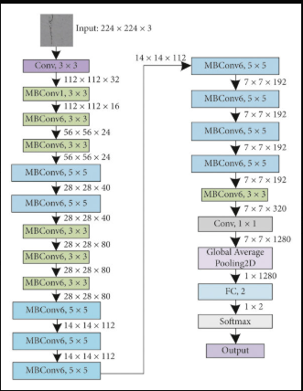

### **3.3.2 ResNet50**

ResNet50 is a deep CNN with 50 layers, known for introducing the concept of residual learning. In very deep networks, accuracy may decrease due to the vanishing gradient problem. ResNet50 addresses this by using shortcut (skip) connections that allow gradients to flow directly through the network without degradation.

The architecture consists of multiple stacked blocks, where each block includes convolutional layers followed by batch normalization and activation functions. The key feature is that each block also adds its input directly to its output, forming a *residual connection*. This helps the model learn identity mappings, making it easier to train very deep networks.

ResNet50 is highly effective in medical image classification, including skin disease detection, because of its ability to capture complex features while maintaining training stability and accuracy.

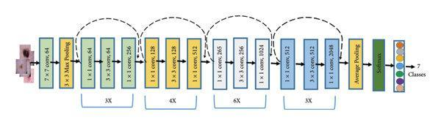

# Figure 3.6 :ResNet50 model Architecture

### **3.3.3 VGG16**

VGG16 is a classical CNN architecture that contains 16 layers, mostly composed of 3x3 convolutional filters followed by max pooling and fully connected layers. It is known for its simple and uniform architecture, which makes it easy to implement and understand.

While VGG16 has a large number of parameters and is computationally intensive, it delivers strong performance in many image classification tasks. The network progresses through increasing depth, extracting richer features at each level before reaching the final softmax classification layer.

VGG16 is often used in academic research and medical imaging tasks like skin disease classification, especially when clarity and explainability of the architecture are important.

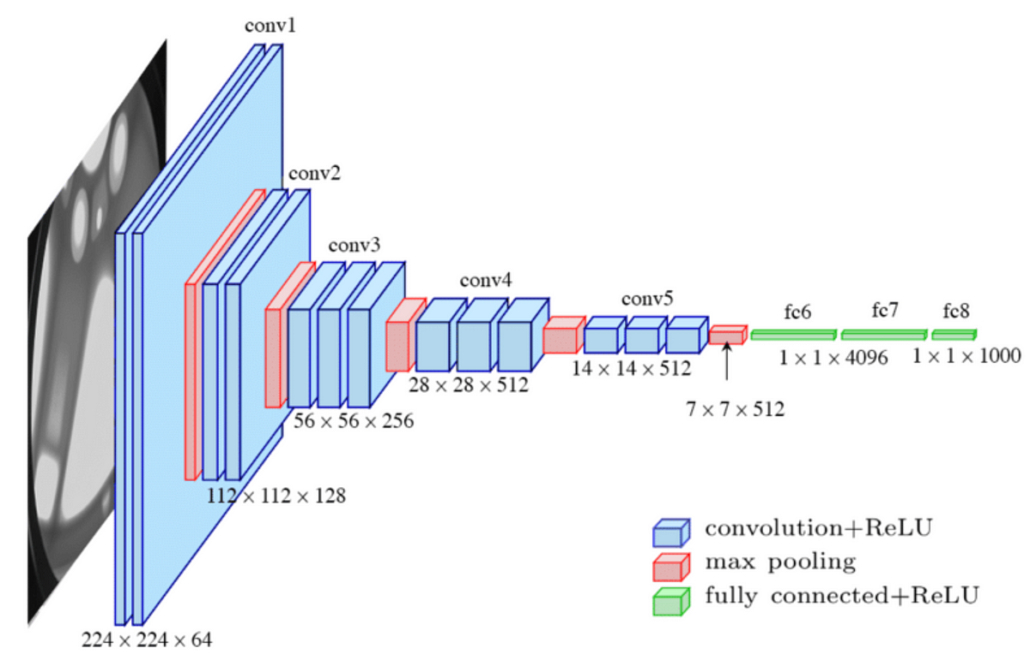

# Figure 3.7 :VGG16 model Architecture

### **3.3.4 InceptionV3**

InceptionV3 is an advanced CNN architecture designed for efficiency and depth. It utilizes Inception modules, which perform several convolutions (1x1, 3x3, 5x5) in parallel within the same layer. This allows the network to extract features at multiple scales simultaneously.

The model incorporates techniques like factorized convolutions, auxiliary classifiers, and label smoothing, making it both accurate and computationally efficient. It is deeper and more optimized than earlier versions of the Inception family.

InceptionV3 is well-suited for complex medical image classification tasks, such as diagnosing skin conditions, because of its ability to learn fine-grained features with high precision.

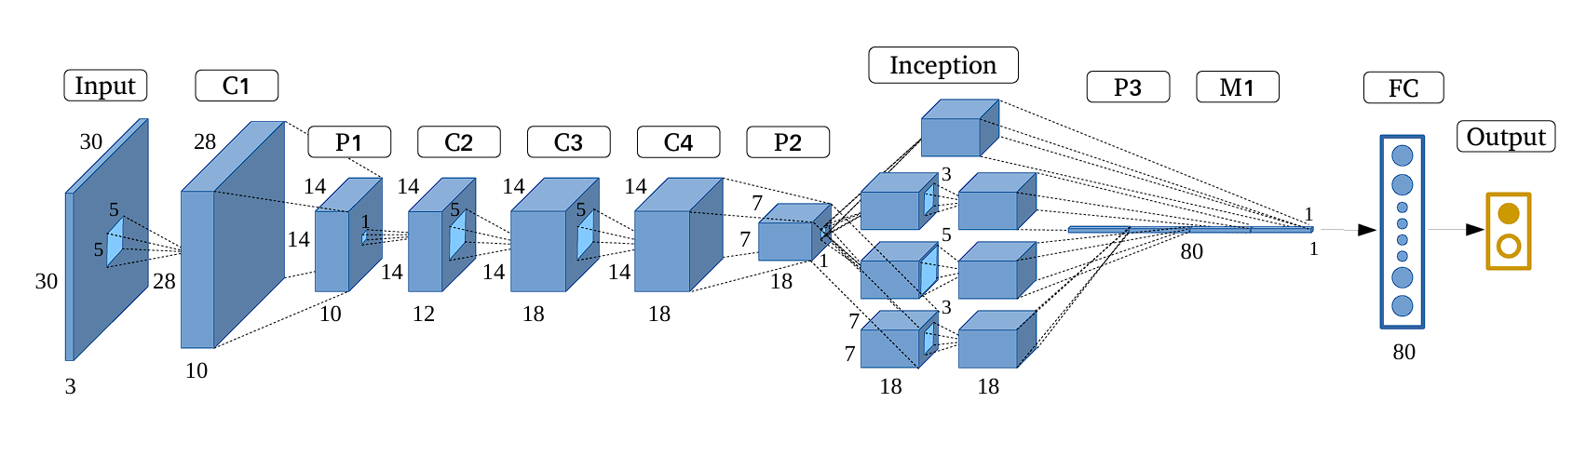

# Figure 3.8 :InceptionV3 model Architecture

### **3.3.5 MobileNetV2**

MobileNetV2 is a lightweight CNN architecture optimized for mobile and embedded devices. It introduces depthwise separable convolutions to reduce computational cost and inverted residual blocks to preserve important features while minimizing parameters.

The architecture is designed to maintain a good balance between speed, efficiency, and accuracy, making it ideal for real-time applications. Despite being smaller and faster than traditional networks, MobileNetV2 still performs well in image classification tasks.

In medical applications like skin disease detection, MobileNetV2 is a preferred choice when deploying on smartphones or resource-limited devices, allowing fast and accurate predictions on the go**.** [5] [6] [7] [8]

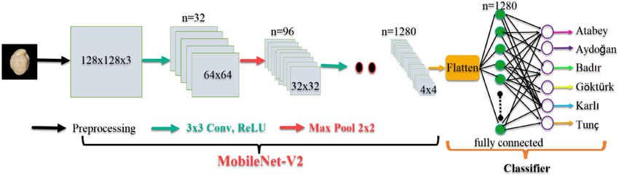

# Figure 3.9: MobileNetV2 model Architecture

## **3.6 Frameworks Used**

### **3.6.1 TensorFlow**

TensorFlow is an open-source deep learning framework developed by Google. It is widely used for building and training neural network models. TensorFlow supports running models on various hardware such as CPUs, GPUs, and TPUs, making it ideal for medical image classification tasks like skin disease detection. It also provides the high-level Keras API, which simplifies the process of designing and training neural networks.

### **3.6.2 Flask**

Flask is a lightweight web framework written in Python used to build web applications and backend servers. In your project, Flask is used to create a simple backend server that receives images from the mobile app, sends them to the AI model for analysis, and returns the diagnosis results to the app. Flask is easy to set up and helps connect your AI model with the external Flutter application.

### **3.6.3 Flutter**

Flutter is an open-source UI framework developed by Google for building cross-platform mobile and web applications with attractive and fast user interfaces. In your project, Flutter is used to develop the mobile app that allows users to upload skin images, receive diagnosis results, and view nearby hospitals based on their location.

### **3.6.4 Firebase**

Firebase is a cloud-based development platform provided by Google that offers a suite of ready-to-use services to simplify app building without the need to create servers or databases from scratch. In your project, Firebase can be used for user data storage, authentication (sign-in), image storage, and app usage analytics. Firebase integrates smoothly with Flutter apps through dedicated libraries that allow easy access to its services. [9] [11]

Chapter 4

# **Implementation**

## **4.1 Technologies, tools, and programming languages used.**

The system was developed using the following technologies and tools:

* **Programming Language:** Python , Dart
* **Framework:** TensorFlow , Kera , Flutter SDK , image_picker , Flask , Firebase
* **Development Environment:** Jupyter Notebook , Google Colab , Android Studio , VS Code
* **Dataset Structure:** Images organized into folders by class (train/test split)
* **File Storage:** Local directories (path-based image loading)

## **4.2 Key components/modules of the system.**

The system consists of the following main components:

**4.2.1 Data Loading and Preprocessing Module**

* Loads images from structured directories
* Resizes images to (224x224)
* Converts them to RGB
* Applies EfficientNet-specific normalization
* Encodes class labels into numerical and one-hot formats

**4.2.1 Model Building Module**

* Utilizes the pretrained EfficientNetB0 as the base model
* Freezes base model weights for transfer learning
* Adds custom dense layers with ReLU and softmax activations
* Compiles the model using the Adam optimizer and categorical cross-entropy loss

**4.2.2 Training Module**

* Trains the model using 80% of the dataset
* Uses batch size of 64 and 20 epochs
* Validates performance on the remaining 20% of the dataset

**4.2.3 Evaluation Module**

* Predicts labels on validation and test sets
* Calculates performance metrics: Accuracy, Precision, Recall, F1-Score, and AUC
* Visualizes confusion matrix and training/validation accuracy and loss curves

**4.2.4 Prediction Module**

* Loads the trained model
* Applies it on new unseen test images
* Outputs predicted class labels for each image

### **4.2.5 Splash Screen Component**

### Displays the app highlights key features..

### Automatically navigates to the Login or Signup screen.

### **4.2.6 Authentication Component**

### Allows users to log in or sign up via the Flutter app.

* Sends authentication requests (login/signup) to the Firebase backend for verification.

### **4.2.7 User Interface Component**

* Shows a list of 8 skin diseases with images, names, and brief descriptions.
* Provides a search bar for easy disease lookup.
* Displays user information (avatar based on gender, username, email) fetched from Firestore .

### **4.2.8 Disease Information Component**

* Presents detailed information about each disease, including symptoms, causes, and prevention.

### **4.2.9 Image Upload & Diagnosis Component**

* Enables users to upload images by taking a photo or selecting from the gallery.
* Uploads images to the Flask backend for analysis.
* Receives and displays diagnosis results returned from the backend.

### **4.2.10 Hospitals Locator Component**

* Shows a “Hospitals” button after diagnosis if a condition is detected.
* Allows users to select their governorate.
* Retrieves and displays a list of hospitals with addresses from Firestore.
* Shows the selected hospital location on a map.

### **4.2.11 Settings Component**

* Supports switching between Light and Dark themes.
* Supports switching between English and Arabic languages.
* Allows users to log out.

### **4.2.12 Backend Component**

* Provides RESTful API endpoints for:

Authentication (login/signup).

Image upload and analysis.

Fetching disease data.

Fetching hospital data.

* Integrates with a database (Firestore or other) to store user, disease, and hospital data.
* Hosts the Machine Learning model for image diagnosis.
* Processes image input and returns diagnosis results to the Flutter app.

## **Challenges faced and how they were resolved.**

During the development of the AI model, we encountered several key challenges that required strategic solutions:

* **Limited Dataset Size**:

Initially, the dataset contained only 1,159 images, which was insufficient for training a robust deep learning model.  
**Solution**: We applied data augmentation techniques to artificially expand the dataset, increasing the total number of images to 4,285. This helped improve the model’s ability to generalize and reduced the risk of overfitting.

* **Random Parameter Selection**:

At first, the model’s hyperparameters (like learning rate, batch size, etc.) were chosen randomly without a structured method, leading to inconsistent performance.  
**Solution**: We implemented **Grid Search**, which systematically explores combinations of hyperparameters to find the best configuration. This approach helped us stabilize and optimize the training process.

* **Hardware Limitations with Increasing Dataset and Classes**:

We considered expanding the number of skin disease classes from 8 to 10. However, due to hardware limitations and the heavy computational cost of running Grid Search on a larger dataset, this was not feasible.  
**Solution**:We decided to maintain the original 8-class setup, balancing between model complexity and system feasibility.  
Throughout the process, we worked on optimizing the model to achieve the best possible performance.  
This focused and well-structured approach allowed us to reach a **validation accuracy of 96%**, demonstrating the model’s effectiveness and our success in addressing the hardware and complexity limitations.

During the development of the Flutter application, we encountered several practical challenges that required creative and technical solutions to ensure a smooth user experience

* **Integrating Flutter with Flask Backend**

One of the main challenges was setting up smooth communication between the Flutter frontend and the Flask backend, especially handling image uploads and receiving diagnosis results.  
**Solution:** We used HTTP requests with proper headers and multipart form data in Flutter to send images. On the Flask side, we ensured correct API routes to accept and process these images, then return results in JSON format.[16][18]

Chapter 5

**Testing & Evaluation**

## **5.1 Testing strategies**

To ensure the quality, reliability, and user satisfaction of the skin disease diagnosis application, a comprehensive testing strategy was employed throughout the development process. This strategy includes three main types of testing:

### **5.1.1 Unit Testing**

Unit testing focuses on verifying the correctness of individual components or functions independently. This allows early detection of bugs and ensures each module behaves as expected.

* Validating input fields such as email and password in the Flutter app.
* Testing theme switching logic between light and dark modes.
* Ensuring the language toggle updates the UI correctly between English and Arabic.
* Verifying backend Flask functions, including image preprocessing and model inference accuracy.

### **5.1.2 Integration Testing**

Integration testing verifies the interactions between different modules to confirm they work together properly, ensuring the system functions as a whole.

* End-to-end testing of image upload from Flutter app to Flask backend and receiving diagnosis.
* Full user authentication flow from sign-up to login and data retrieval.
* Checking UI updates propagation, such as language changes across multiple screens.

### **5.1.3 User Testing**

User testing assesses usability and user experience by involving real users to perform typical tasks and providing feedback for improvements

* Tasks included account registration, image uploading, diagnosis review, and hospital search.
* Feedback was collected on UI clarity, button labeling, and upload responsiveness.
* Resulted in improvements to button labels, and image upload performance.

## **5.2 Performance metrics**

We evaluated our model using several key performance metrics to ensure effectiveness:

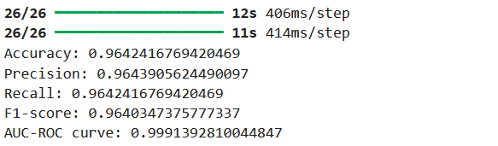

# Figure 3.10 : Accuracy of model

These metrics indicate a highly accurate and reliable model for skin disease classification. We also optimized the training pipeline for speed and resource efficiency to enable smooth training on limited hardware. Scalability was considered, but constrained by hardware limitations, leading us to focus on 8 classes instead of expanding to more.

## **5.3 Comparison with existing solutions**

Our approach focuses on diagnosing 8 specific skin diseases with high accuracy, achieving results that surpass many existing studies that either limit themselves to fewer diseases or only perform binary classification (disease presence or absence) rather than precise diagnosis. While some prior works have focused on limited classifications, this model reaches a balanced and effective solution suitable for real-world applications.

Chapter 6

# **Results & Discussion**

## **6.1 Introduction**

This chapter presents a comprehensive overview of the results obtained from implementing the AI-powered skin disease classification system and the mobile application built with Flutter. The project aimed not only to develop an accurate machine learning model but also to integrate it into a practical, user-friendly mobile app that allows users to upload an image, receive a diagnosis, and access useful medical information and nearby hospital recommendations.

The system was developed in two interconnected phases:

* **Phase 1:** Training a deep learning model using the EfficientNetB0 architecture to classify 8 common skin diseases.
* **Phase 2:** Building a cross-platform Flutter app that enables user interaction, disease information browsing, image uploading, and diagnosis retrieval. [4]

## **6.2 Summary of Findings**

#### **6.2.1 AI Model Results:**

* The dataset was expanded from 1,159 to 4,285 images using data augmentation techniques to improve generalization.
* After fine-tuning the EfficientNetB0 model with grid search, the following results were achieved:
  + **Accuracy:** 96.42%
  + **Precision:** 96.44%
  + **Recall:** 96.42%
  + **F1-Score:** 96.40%
  + **AUC-ROC:** 0.9991

These results indicate a highly accurate and dependable model suitable for real-world classification of skin diseases.

#### 

#### **6.2.2 Flutter App Results:**

* The app was developed using Flutter with a bilingual interface (Arabic and English).
* Key features include:
  + Login and registration system
  + Image upload via camera or gallery
  + Real-time diagnosis using the Flask backend
  + Detailed disease information (symptoms, causes, prevention)
  + Hospital locator based on governorate selection
  + Dark/light mode toggle and multi-language support
* The app delivers a smooth and intuitive experience for users of all ages.

## **6.3 Interpretation of Results (Did the project meet its objectives?)**

Yes, the project successfully achieved its main objectives:

* Developed an accurate and robust AI model for diagnosing 8 skin diseases.
* Integrated the model into a user-friendly mobile application with real-world functionality.
* Achieved strong performance metrics (over 96% accuracy).
* Provided educational content and location-based support within the app.

The solution not only delivers accurate medical insights but also guides users toward further medical assistance—making it a complete diagnostic and support system.

## **6.4 Limitations of the proposed solution**

Despite the promising results achieved by the overall skin disease diagnosis application, several limitations should be considered:

* **Limited Disease Coverage** The AI model currently supports only eight skin conditions, which limits its effectiveness in diagnosing rare or complex dermatological cases.
* **Sensitivity to Image Quality**

The accuracy of the diagnosis may be affected by unclear, low-resolution, or poorly lit images captured in uncontrolled environments.

* **No Real-Time Medical Consultation**

The system does not provide direct communication with dermatologists for follow-up or second opinions.

* **Static Hospital Information**

Hospital data is stored statically in Firestore and is not dynamically updated from official health sources.

Chapter 7

# **Conclusion & Future Work**

## **7.1Conclusion**

This project is primarily designed to improve the early detection and accurate diagnosis of various dermatological (skin-related) diseases by leveraging advanced technological methods, especially deep learning techniques. Early diagnosis is critical because it increases the chances of effective treatment and can significantly minimize the risks associated with delayed medical intervention.

The project’s scope extends beyond merely identifying skin conditions. It also emphasizes offering actionable preventive advice. This means that once a condition is detected, users are also provided with practical tips and recommendations on how to manage or prevent the worsening or spread of the disease. This proactive approach is vital for controlling contagious skin diseases and promoting healthier practices among individuals.

By providing a reliable, easy-to-use diagnostic tool, users can quickly get a preliminary diagnosis and take timely actions to seek professional care if necessary. This can lead to faster intervention, better management of symptoms, and an overall reduction in healthcare costs, until visit the nearest doctor.

Moreover, the integration of deep learning models highlights how modern AI (AI) can be effectively applied in the healthcare sector. Deep learning allows the system to learn from a vast amount of skin disease images, improving its diagnostic accuracy over time. By doing so, the project not only offers more accessible healthcare solutions but also contributes to the future vision of technology-driven preventive healthcare. [4]

## **7.2 Future Work:**

In the previous section, the implemented features were stated. In this section the new features that could be added to application, will be introduced, plus additional points.

The main system for applications is related to future work :

**1. Expanding the Disease Categories**

Adding more skin diseases to the current list to cover a wider range of conditions and improve diagnostic capabilities.

### **2. Enhancing and Exploring Model Performance**

Improving the overall classification performance by refining the training dataset, optimizing preprocessing techniques, and experimenting with alternative model architectures such as Vision Transformers, InceptionV3, and MixNet to identify the most effective solution.

### **3. Integrating Doctor Consultation Feature**

Allowing users to book appointments with dermatologists directly through the app after receiving a diagnosis.

### **4. Diagnosis History Log**

Storing each user's diagnosis history for future reference and follow-up, enabling better health tracking.

### **5. Offline Mode**

Providing access to essential features and previously loaded data even when the user is not connected to the internet.

### **6. Multilingual Support**

Adding support for additional languages such as French and German to make the app accessible to a broader audience.

# **References**

# 

# 

# 

# 

# 

# 

# 

# 

# [1]Jagdish, M. J., Gualán Guamangate, S. P., García López, M. A., De La

# Cruz‑Vargas, J. A., & Roque Camacho, M. E. (2022). Advance study of skin

# diseases detection using image processing methods. *Natural Volatiles &*

# *Essential Oils*, *9*(1), 997–1007.

# [2] Vakalopoulou, M., Christodoulidis, S., Burgos, N., Colliot, O., & Lepetit, V.

# (2025). *Deep learning: Basics and convolutional neural networks (CNN).* In O.

# Colliot (Ed.), *Machine Learning for Brain Disorders* (Chapter 3). Springer.

# [3] GVP College of Engineering for Women. (2023). Skin detection using

# image processing and machine learning. *Research Square*.

# [4] Raj, A., & Sharma, P. (2020). An overview of CNN architectures and

# applications. *International Journal of Computer Science and Information*

# *Security*, *18*(3), 55–65

# [5] Krizhevsky, A., Sutskever, I., & Hinton, G. E. (2012). ImageNet

# <https://www.kaggle.com/datasets/subirbiswas19/skin-disease-dataset/data>

# [6] Simonyan, K., & Zisserman, A. (2015). Very deep convolutional networks

# for large-scale image recognition. *International Conference on Learning*

# *Representations (ICLR)*.

# [7] Howard, A. G., Zhu, M., Chen, B., Kalenichenko, D., Wang, W., Weyand,

# T., ... & Adam, H. (2017). MobileNets: Efficient (SNNs) for mobile vision

# applications. *arXiv preprint arXiv:1704.04861*.

# [8] Goodfellow, I., Bengio, Y., & Courville, A. (2016). *Deep learning*. MIT

# Press.

# [9] Flutter Documentation. (n.d.). Retrieved from<https://docs.flutter.dev/>

# [10] Biswas, S. (n.d.). Skin disease dataset. Retrieved from

# [11] Meehan, T. (2019). *Pragmatic Flutter*.

# [12] LeCun, Y., Bengio, Y., & Hinton, G. (2015). Deep learning. *Nature*,

# *521*(7553), 436–444.<https://doi.org/10.1038/nature14539>

# [13] Chollet, F. (2017). *Deep learning with Python*. Manning Publications.

# (14) Biswas, S. (n.d.). Skin disease dataset. Retrieved from<https://www.kaggle.com/datasets/subirbiswas19/skin-disease-dataset/data>

# [15] AlEnezi, N. S. A. (2019). A method of skin detection using image

# processing and machine learning. *Procedia Computer Science*.

# [16] Miola, A. (2020). *Flutter complete reference*.

# [17] Flutter Community. (n.d.). Flutter widgets catalog. Retrieved from

# <https://flutter.dev/docs/development/ui/widgets>

# [18] Firebase. (n.d.). Firebase features and capabilities. Retrieved from

# <https://firebase.google.com/products>

# [19] Firebase Flutter. (n.d.). Retrieved from<https://firebase.flutter.dev/>

Chapter 8

# **Appendices**

**8.1 Introduction to the AI Model**

The AI model used in this project is based on a CNN, specifically the well-known EfficientNetB0 architecture, which is widely recognized for its high performance in image classification tasks. The model was trained on a dataset of labeled skin disease images to learn how to distinguish between eight different dermatological conditions. It includes multiple layers that extract important visual features from images, which are resized to a uniform dimension of 128×128 pixels for consistent input processing. After training, the model can analyze a new image and provide the most likely diagnosis along with the confidence level for each possible class. The model has demonstrated promising results in identifying the targeted skin diseases, making it a useful tool for initial diagnostic support.

### **8.1.1 Explain Dataset**

As previously mentioned, one of the key challenges we initially faced was the limited size of the dataset, which originally consisted of only 1,159 images distributed across 8 skin disease categories. This small dataset size posed a significant obstacle to effectively training a deep learning model, as such models typically require large volumes of data to generalize well and avoid overfitting.

To overcome this limitation, we applied data augmentation techniques—such as image rotation, flipping, zooming, and color adjustments—to artificially expand the dataset while preserving the medical relevance of each image. As a result, we successfully increased the dataset size to 4,285 images.

* In this dataset image collected .
* The dataset consists of 4285 images categorized into 8 skin diseases.
* The data is divided into two subsets: 80% (4052 images) for training and 20% (233 images) for testing.

|  |  |  |  |
| --- | --- | --- | --- |
| **Disease** | **Training Images** | **Testing Images** | **Total Images** |
| **Cellulitis** | 879 | 33 | 912 |
| **Impetigo** | 440 | 20 | 460 |
| **Athlete's Foot** | 418 | 32 | 450 |
| **Nail Fungus** | 516 | 33 | 549 |
| **Ringworm** | 450 | 23 | 473 |
| **Cutaneous Larva Migrans** | 378 | 30 | 408 |
| **Chickenpox** | 493 | 34 | 527 |
| **Shingles** | 478 | 33 | 511 |
| **Total** | 4052 | 233 | 4285 |

# Table 8.1 :Dataset

# Figure 8.1 :Sample of Dataset

# Figure 8.2 :Data Augmentation

# Figure 8.3: Grid Search

Grid Search is a technique used to find the best combination of hyperparameters for a model , It works by Defining a set of values for each hyperparameter (like learning rate, batch size, number of layers, etc.)

Figure 8.4 : Best Parameters of Grid Search

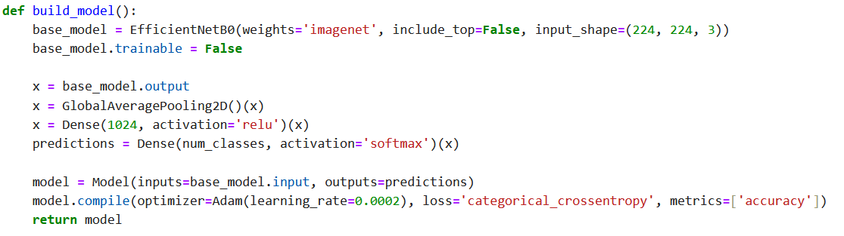

# Figure 8.5 : Build The Model using EfficientNetB0

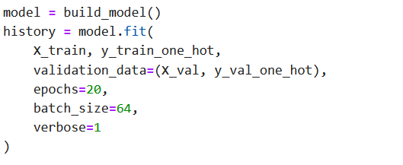

# Figure 8.6 : Training Model



# Figure 8.7: Evaluating Model

After training, we check the model’s performance on the validation set to measure accuracy and see how well it generalizes to unseen data.

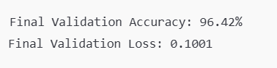

# Figure 8.8 :Final Performance

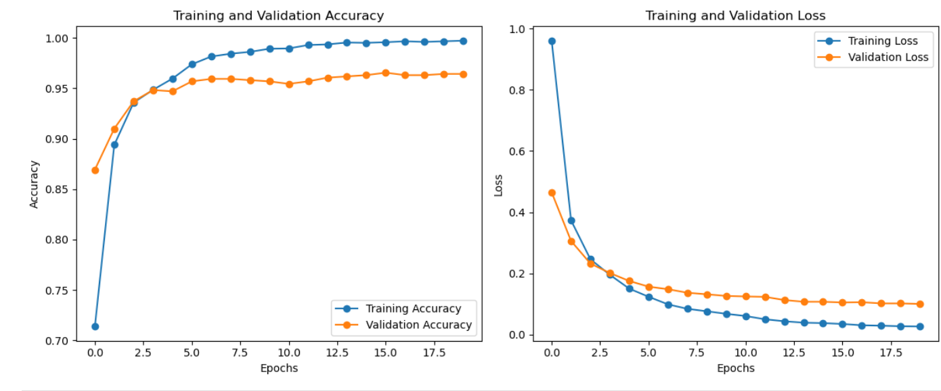

# Figure 8,9 : Visualizing Training Performance

The plots show the change in **accuracy** and **loss** over epochs, confirming the model is learning effectively without overfitting.

# 

# Figure 8.10 : Prediction on Test Set

This code loads test images, preprocesses them, uses the trained model to predict their classes, and compares predictions with the real labels

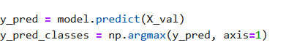

# Figure 8.11 :Generate Prediction

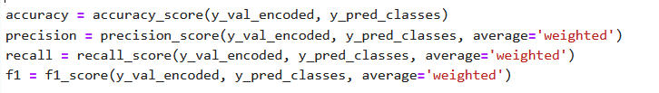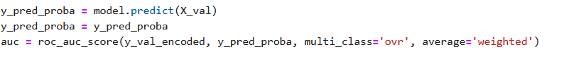

# Figure 8.12: calculate Evaluation Metrics

We calculate accuracy, precision, recall, and F1-score to measure how well the model correctly classifies the validation data.The AUC-ROC score reflects the model’s ability to distinguish between classes (the higher, the better).

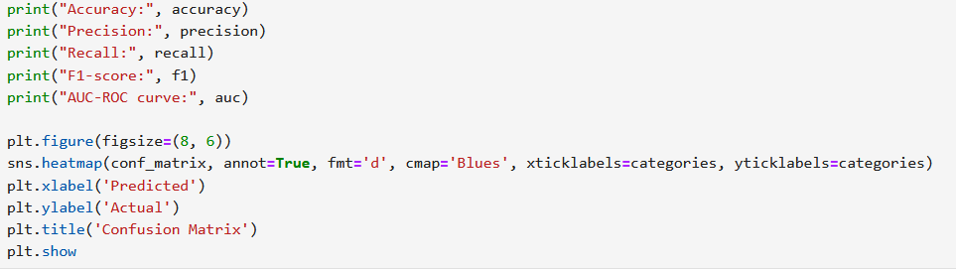

# Figure 8.13 : code of Matric Results & Confusion Matrix

This section prints the main evaluation metrics (accuracy, precision, recall, F1, and AUC), then visualizes the confusion matrix to show how well the model classified each class.

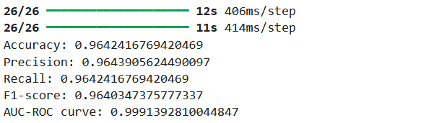

Figure 8.14 : Final Evaluation Metrics on Validation Set

These results show that the model performs very well on the validation set, with high accuracy, precision, recall, F1-score, and an almost perfect AUC-ROC score.

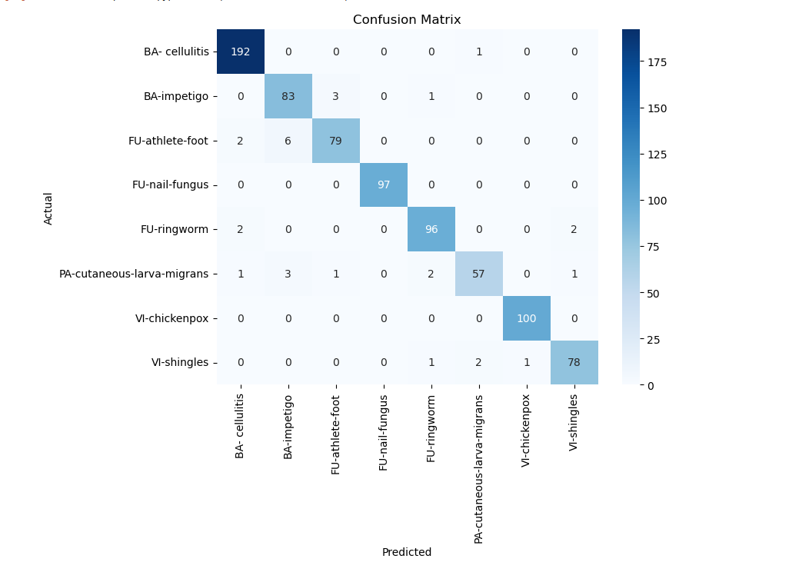

Figure 8.15 :Confusion Matrix Visualization

## **8.2 Introduction to Flutter**

In the following section, I will present an overview of Flutter, the mobile development framework used to build the user interface of the application. This section will cover the main structure of the Flutter project, key functionalities implemented in the app, and how Flutter was used to connect with the backend and provide a smooth user experience. Flutter played a central role in building the app's interactive features, multilingual support, dark/light theme toggling, and seamless communication with Firebase and the diagnostic server.

### **8.2.1 Splash Screen**

The application opens with an animated Splash Screen that automatically cycles through four introduction pages. These pages highlight the main features of the app, and after the final screen, the user is directed to the Home Page.

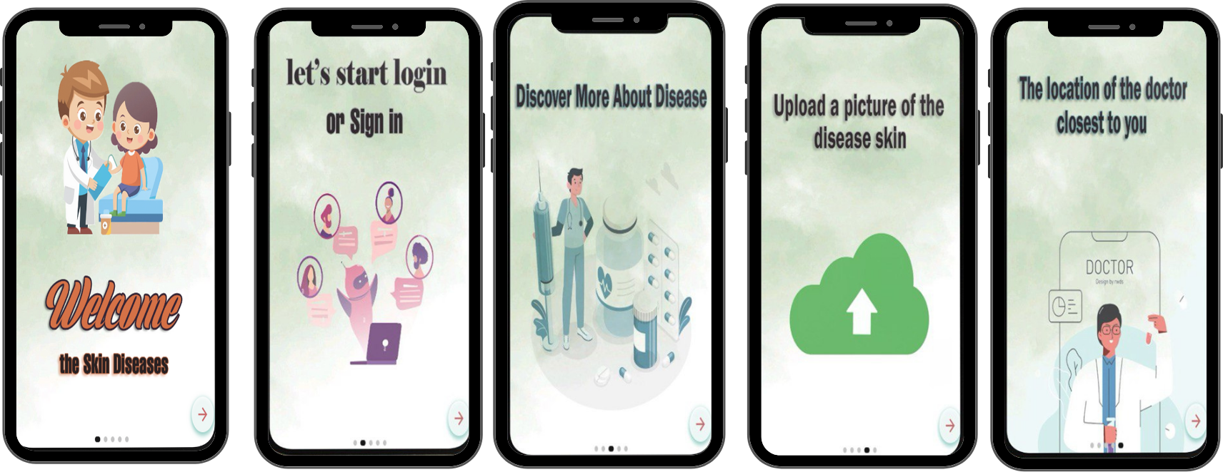

# Figure 8.16 : Splash Screen

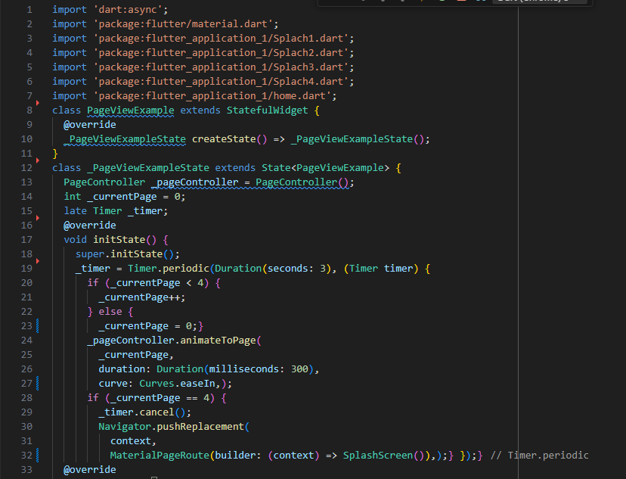

# Figure 8.17 : Code Splash Screen P1

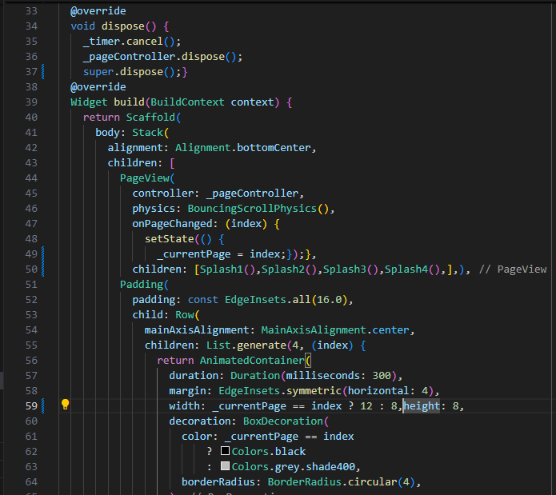 Figure 8.18 : Code Splash Screen P2

### **8.2.2 Home Screen(After Splash Screen)**

The final Splash Screen displays the app title, logo, and two main options: login and create account. It allows users to proceed to authentication and supports localization using easy_local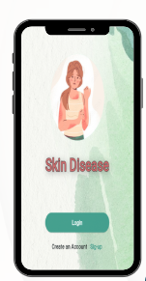

Figure 8.19 : Home Screen

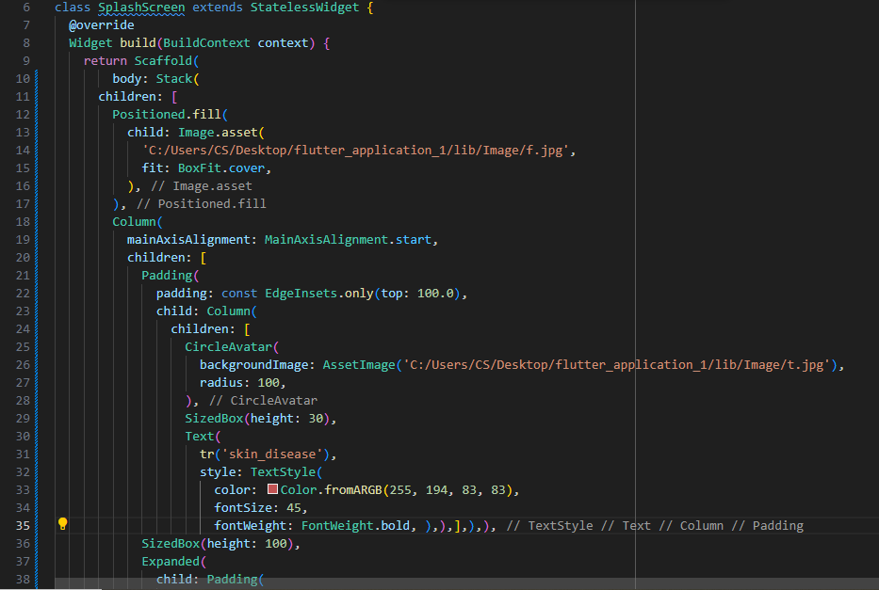Figure 8.20 : Code Home Screen P1

# Figure 8.21 : Code Home Screen P2

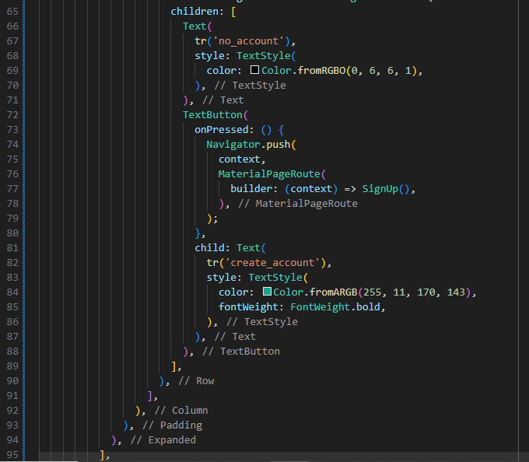Figure 8.22 : Code Home Screen P3

**8.2.3 Login Screen**

The login screen allows users to securely sign in using their email and password. It includes input validation, password visibility toggle, and error handling for incorrect credentials.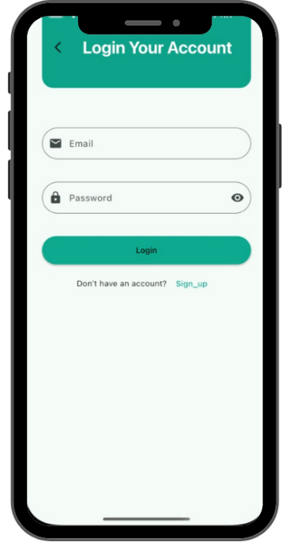

Figure 8.23 : Login Screen

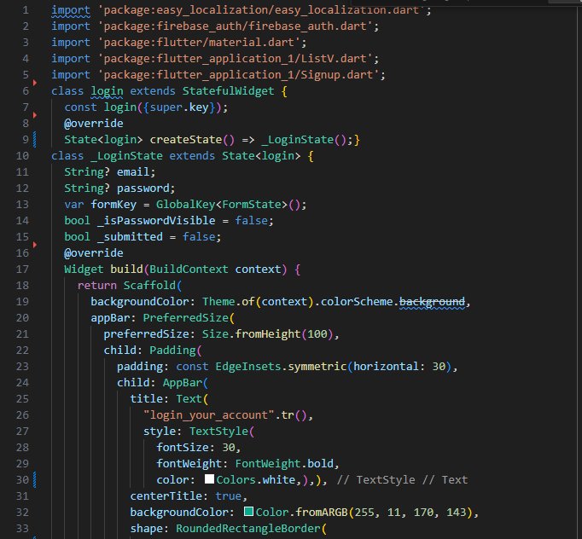

Figure 8.24 : Code Login Screen P1

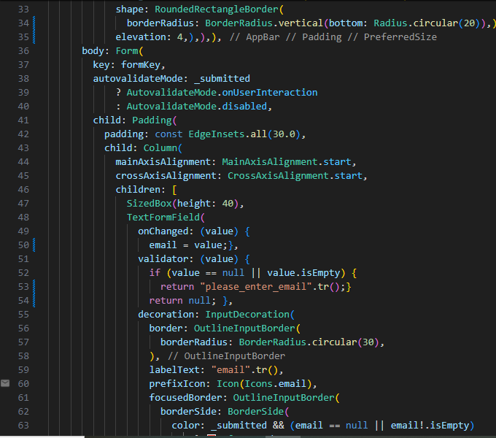Figure 8.25 : Code Login Screen P2

Figure 8.26 : Code Login Screen P3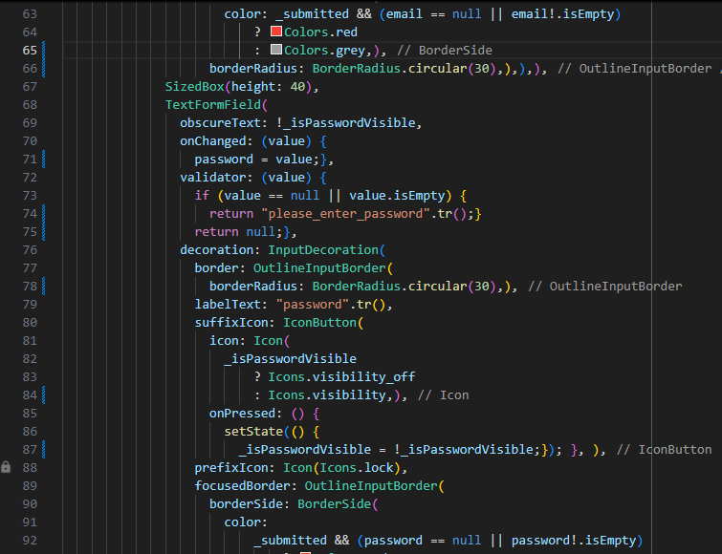

# 

Figure 8.27 : Code Login Screen P4

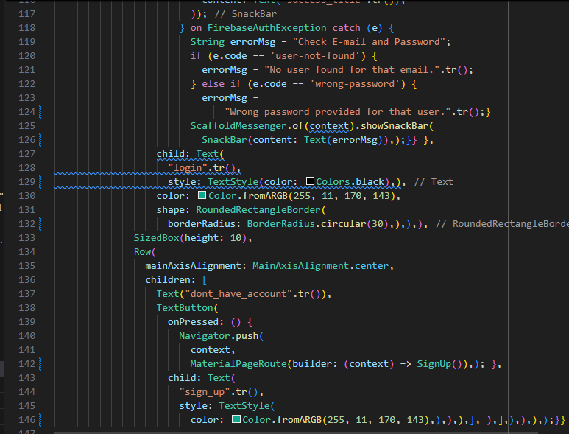Figure 8.28 : Code Login Screen P5

**8.2.4 Sign Up Screen**

This is a "Sign Up" interface built using Flutter and Firebase. When a user enters their details such as username, email, password, date of birth, and gender, the app first validates that all fields are filled in correctly. Once the validation is successful, Firebase Authentication is used to create a new account with the provided email and password. Additional user information like name, date of birth, and gender is then saved in Firestore. If the registration is successful, the user is redirected to the login screen. In case of errors, such as a weak password or an already registered email, an appropriate error message is displayed to the user.

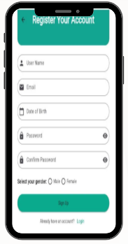

# Figure 8.29 : Sign UpScreen

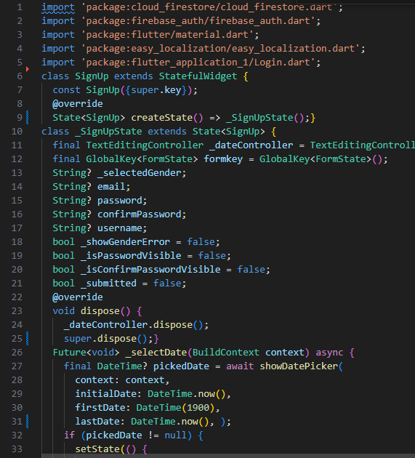

# Figure 8.30 : Code Sign Up Screen P1

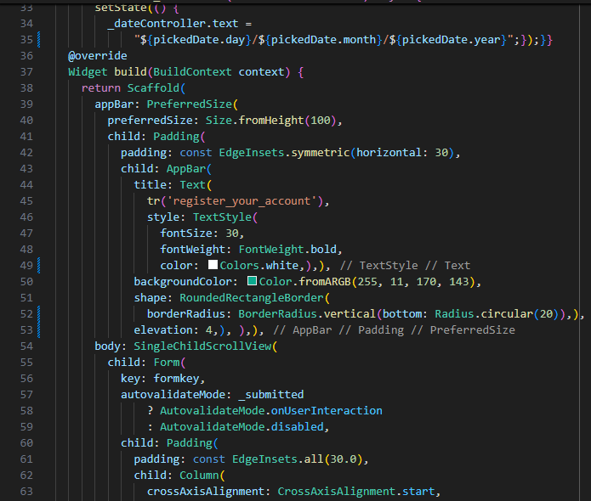Figure 8.31 : Code Sign Up Screen P2

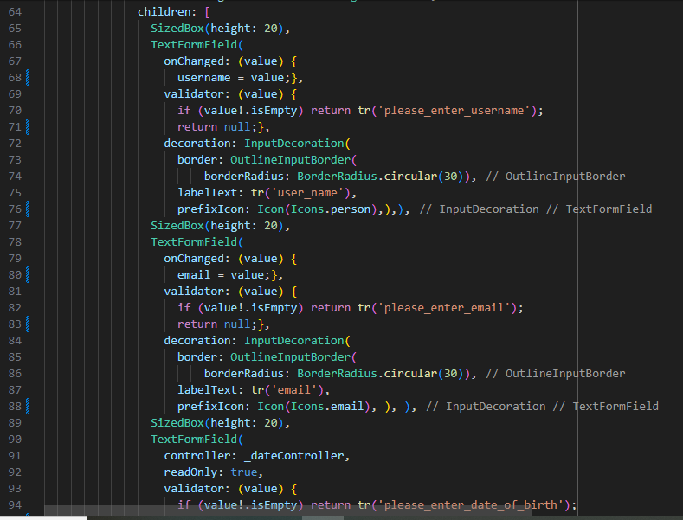

# Figure 8.32 : Code Sign Up Screen P3

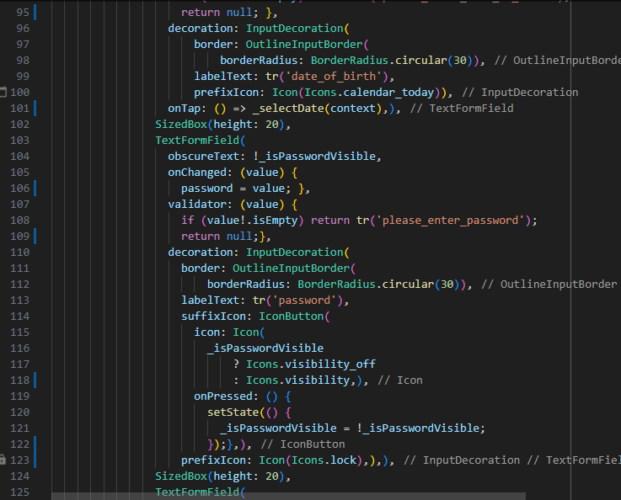Figure 8.33 : Code Sign Up Screen P4

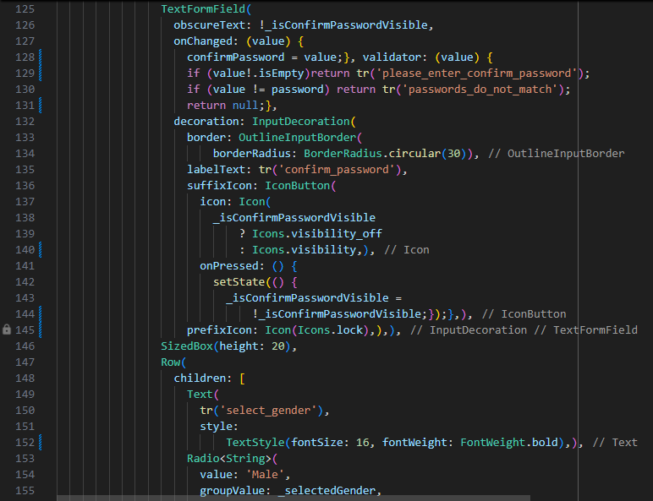

# Figure 8.34 : Code Sign Up Screen P5

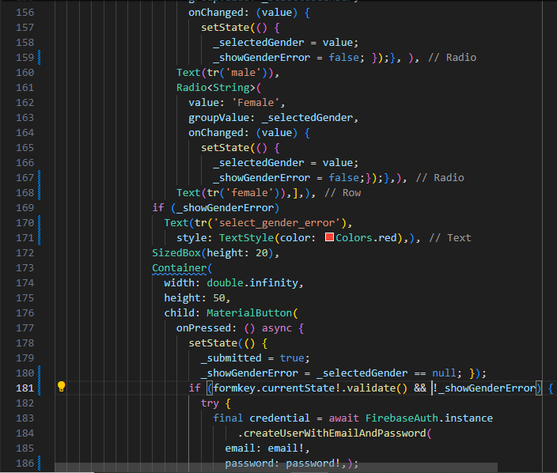Figure 8.35 : Code Sign Up Screen P6

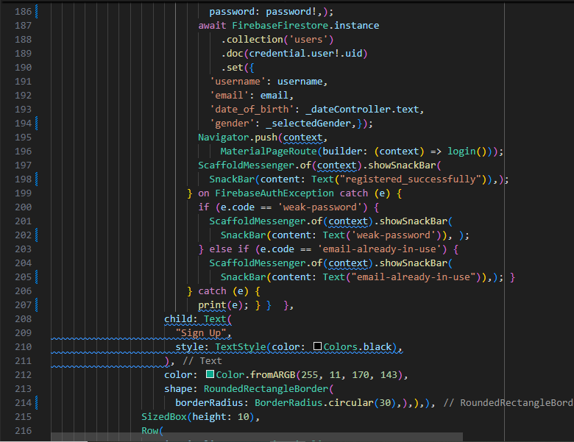

# Figure 8.36 : Code Sign Up Screen P7

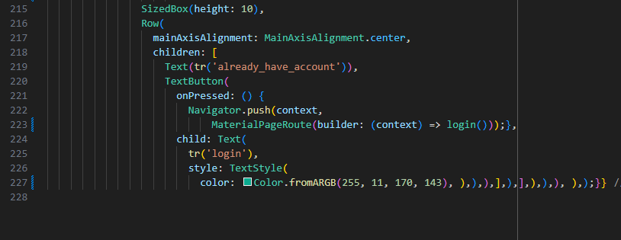

# Figure 8.37 : Code Sign Up Screen P8

### **8.2.4 The Diseases Screen**

This page is accessible after the user successfully logs in or signs in to the application. It provides an overview of eight common skin conditions, each displayed with an image, name, and brief description. Users can search for diseases by name, making it easy to find specific conditions. Tapping on "Read More" takes the user to a detailed page for each disease

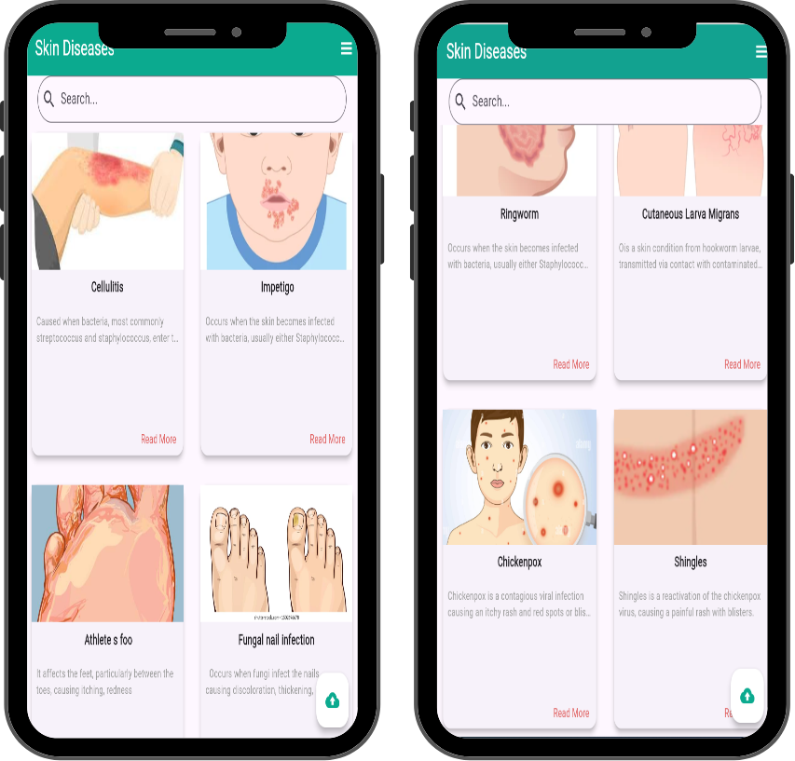

# Figure 8.38 : The Diseases Screen

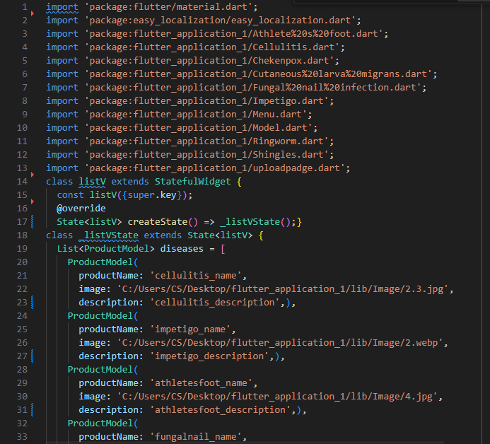

# Figure 8.39 : Code Diseases Screen P1

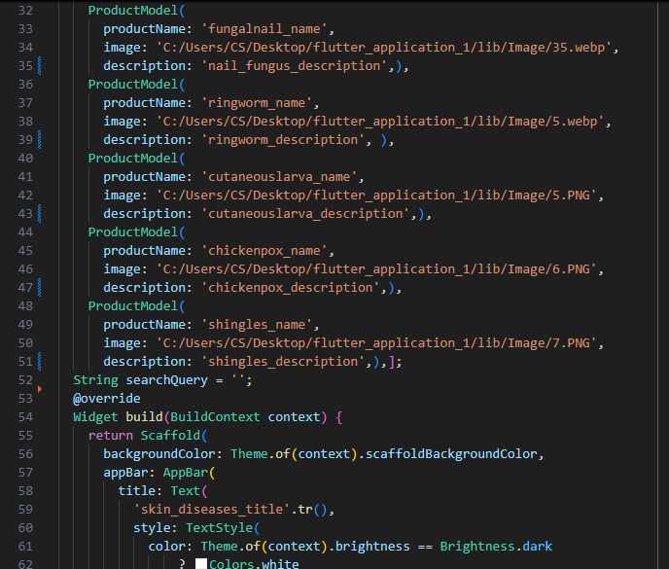

Figure 8.40 : Code Diseases Screen P2

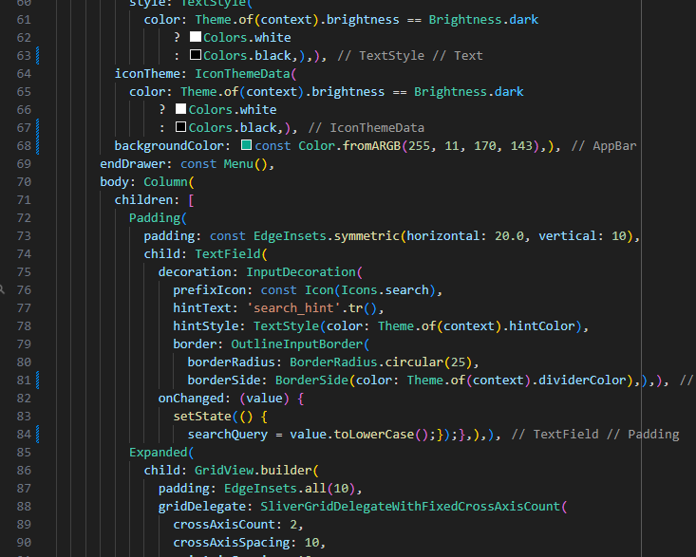

# Figure 8.41 : Code Diseases Screen P3

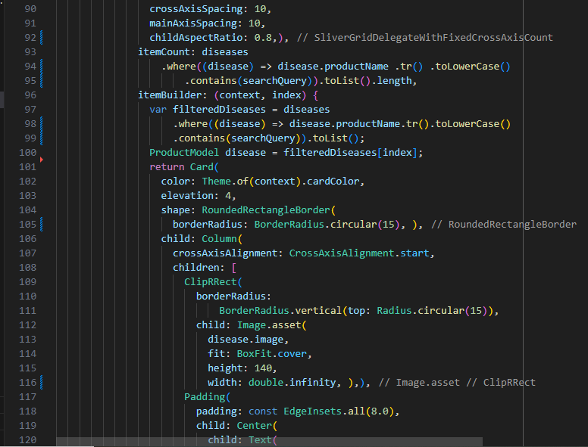Figure 8.42 : Code Diseases Screen P4

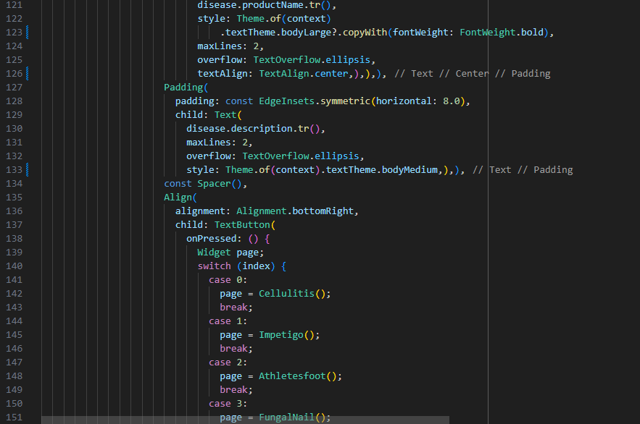

Figure 8.43 : Code Diseases Screen P5

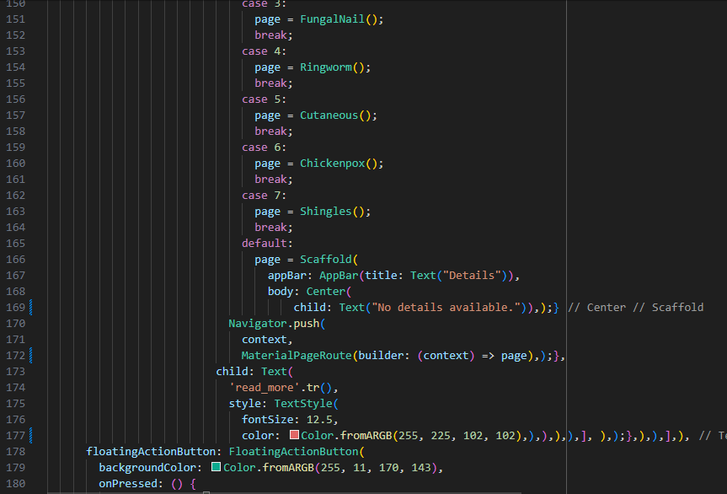Figure 8.44 : Code Diseases Screen P6

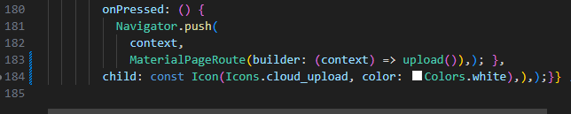

# Figure 8.45 : Code Diseases Screen P7

### **8.2.5 Disease Detail Screen**

A unified template was developed using a custom widget called DiseasePageTemplate to display information about skin diseases. This template presents the disease name, image, and distinct sections for symptoms, causes, and prevention. It supports both dark and light themes, as well as multilingual translations. The template is applied to individual disease pages, by passing specific keys, image paths, and descriptions for each condition. This approach was implemented for 8 different skin diseases to ensure a consistent, organized, and user-friendly presentation.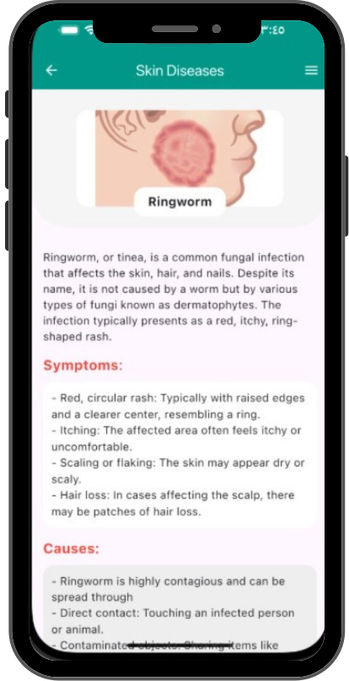

# Figure 8.46 : Disease Detail Screen

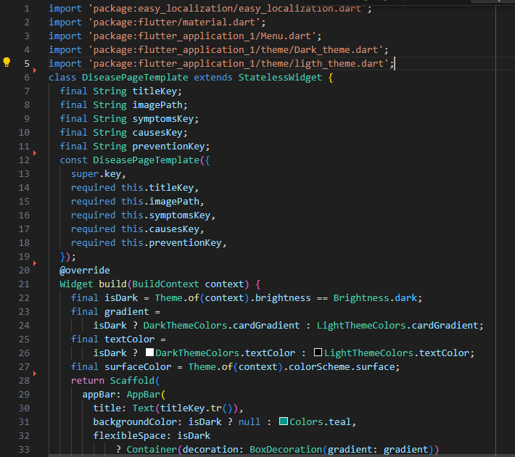

# Figure 8.46 : Code DiseasePageTemplate p1

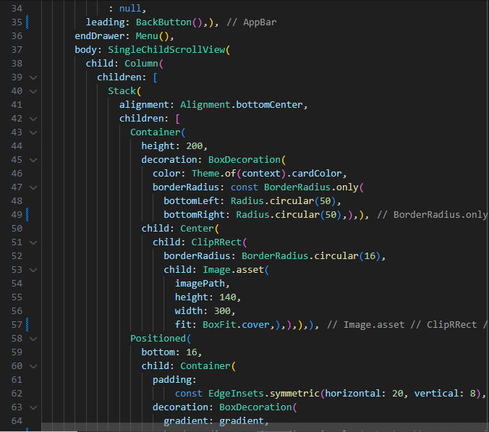Figure 8.47 : Code DiseasePageTemplate p2

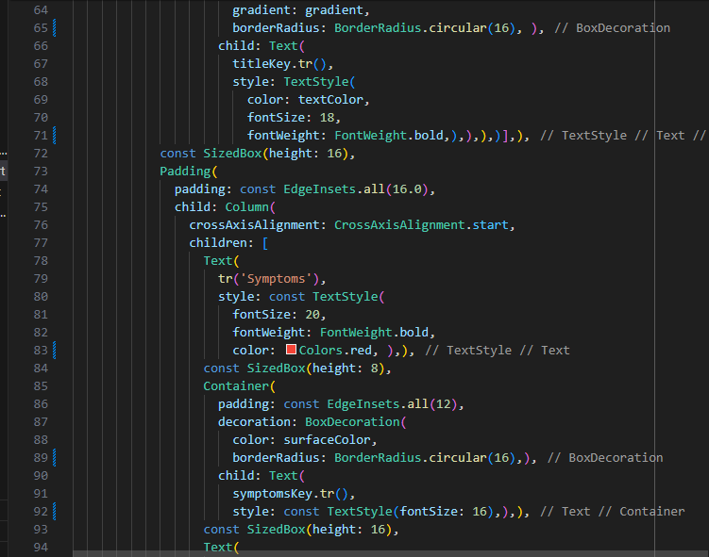

Figure 8.48 : Code DiseasePageTemplate p3

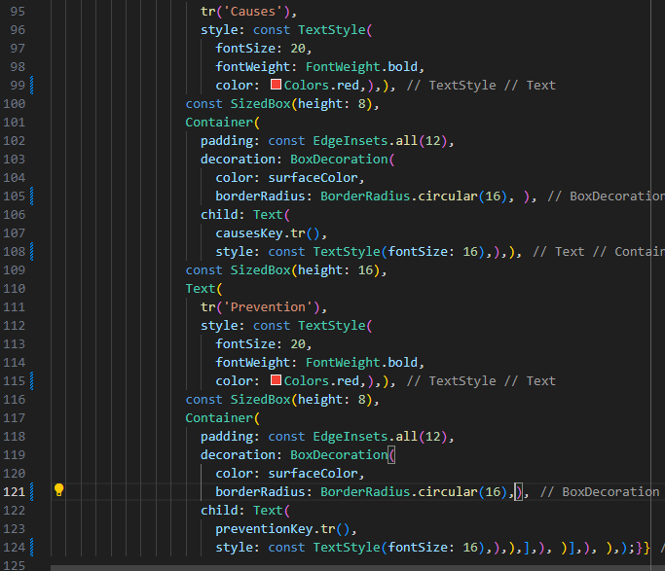

# Figure 8.49 : Code DiseasePageTemplate p4

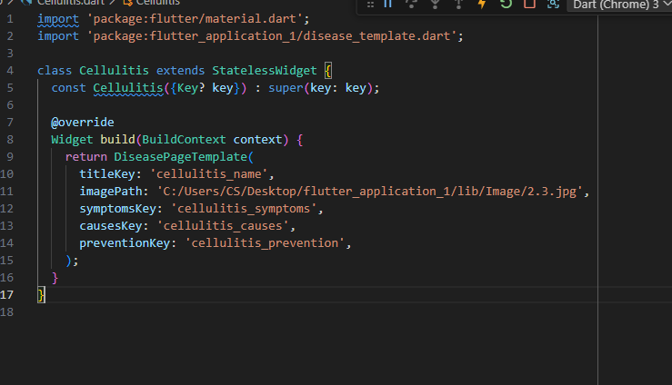

# Figure 8.50 :Code Disease Detail Screen

### **8.2.6 Image Upload Screen**

This page allows users to upload an image of a skin condition using either the camera or gallery. The uploaded image is then sent to a Flask-based backend to initiate an AI-powered diagnosis that identifies skin conditions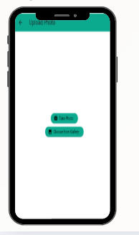

# Figure 8.51 : Image Upload Screen

### 

Figure 8.52 : Code Image Upload Screen p1

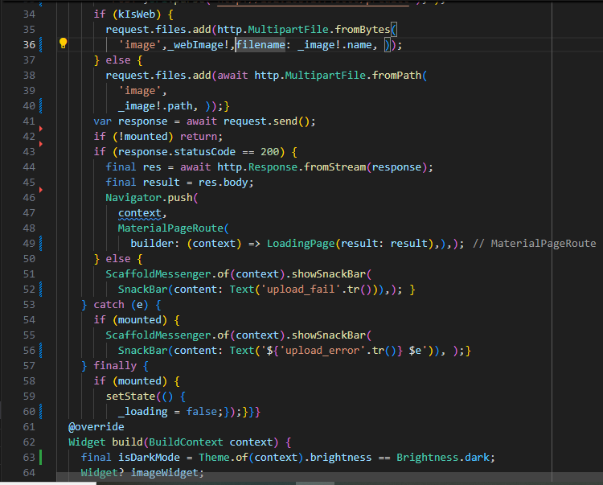 Figure 8.53 : Code Image Upload Screen p2



Figure 8.54 : Code Image Upload Screen p3

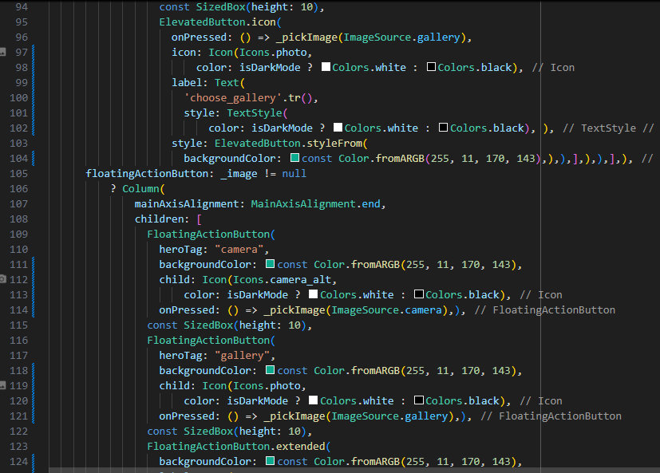

Figure 8.55 : Code Image Upload Screen p4

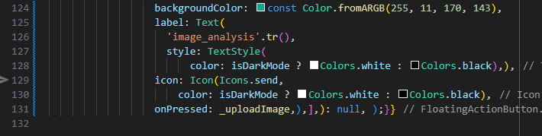

Figure 8.56 : Code Image Upload Screen p5

### **8.2.7 Loading Screen**

This page appears immediately after the user uploads a skin condition image. It simulates an AI diagnosis process by showing a loading indicator until the analysis is completed.

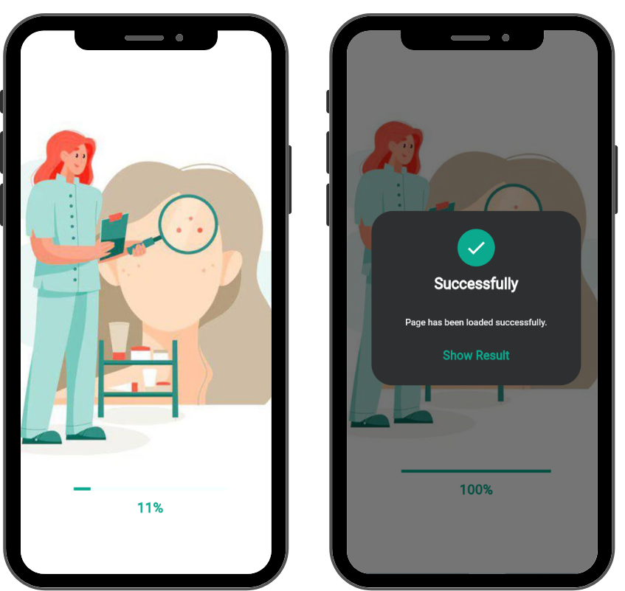

# Figure 8.57 : Loading Screen

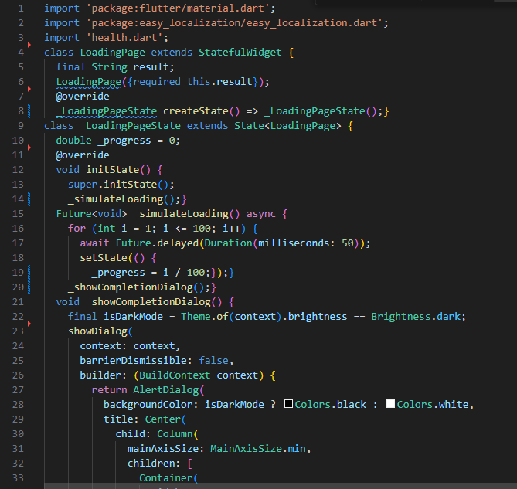

Figure 8.58 : Code Loading Screen p1

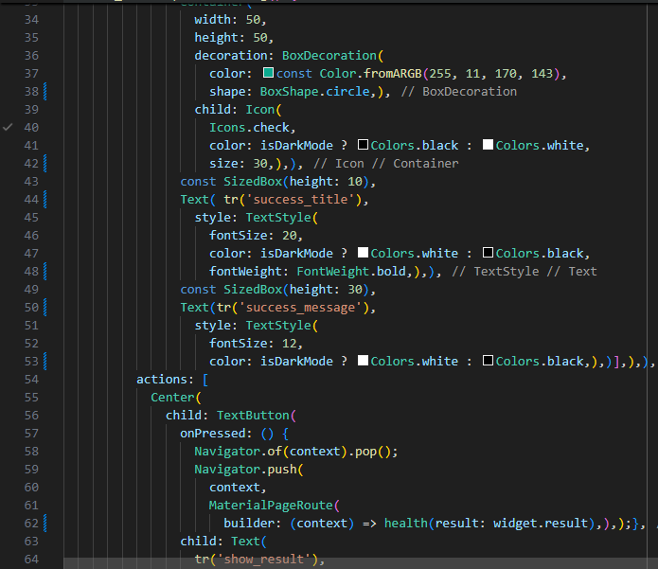 Figure 8.59 : Code Loading Screen p2

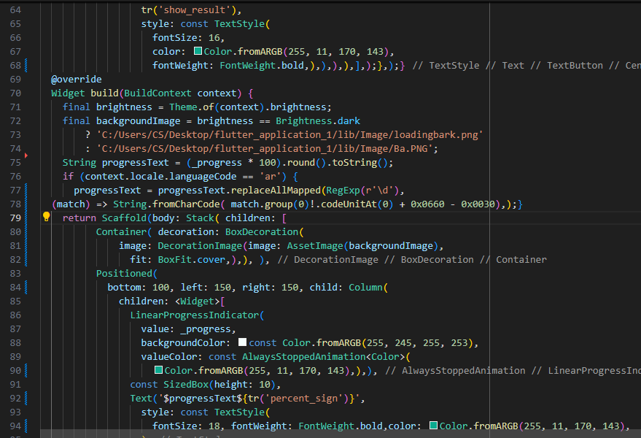

Figure 8.60 : Code Loading Screen p3

### **8.2.8 Diagnosis Result Screen**

This page displays the AI-generated diagnosis result based on the uploaded image. It shows the predicted skin condition, the confidence percentage, and gives a recommendation along with a navigation option to hospitals. If the confidence level is low, it informs the user that no disease was detected.

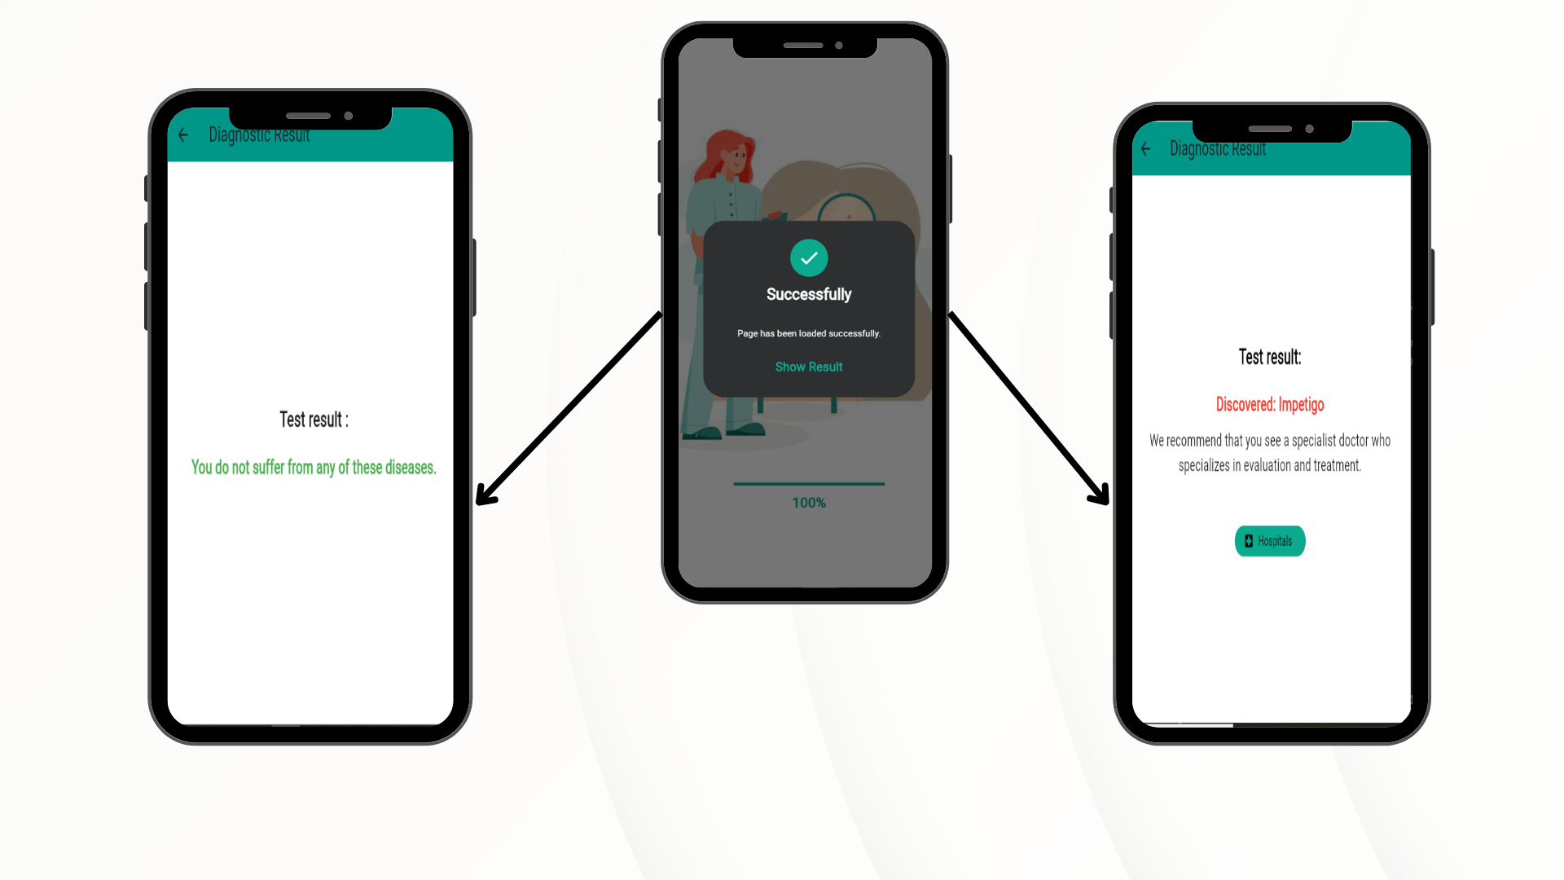

Figure 8.61: Diagnosis Result Screen

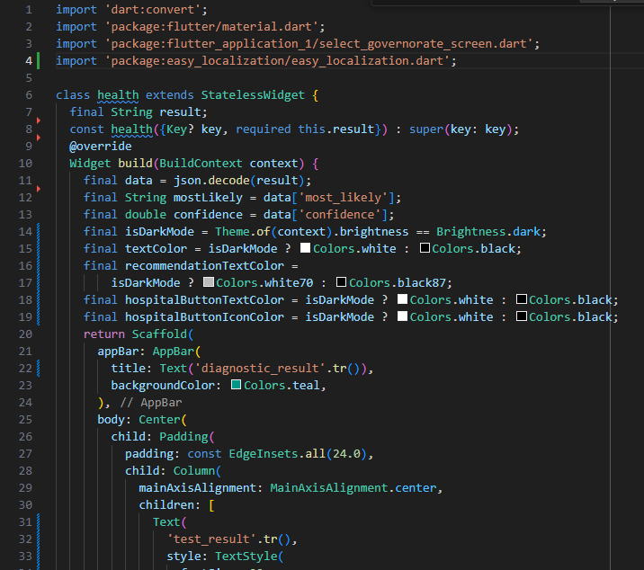

Figure 8.62 : Code Diagnosis Result Screenp1

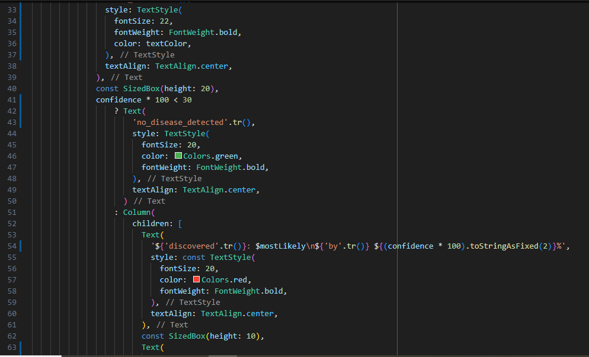Figure 8.63 : Code Diagnosis Result Screenp2

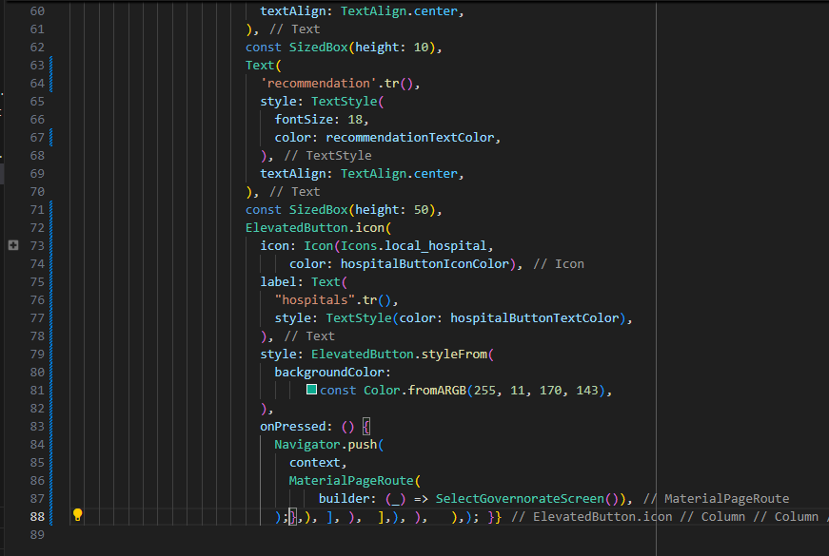

Figure 8.64 : Code Diagnosis Result Screenp3

### **8.2.9 Select Governorate Screen**

This page allows the user to choose their governorate to display a list of nearby hospitals. It serves as a location-based filter after receiving a diagnosis result, helping users find relevant medical facilities.

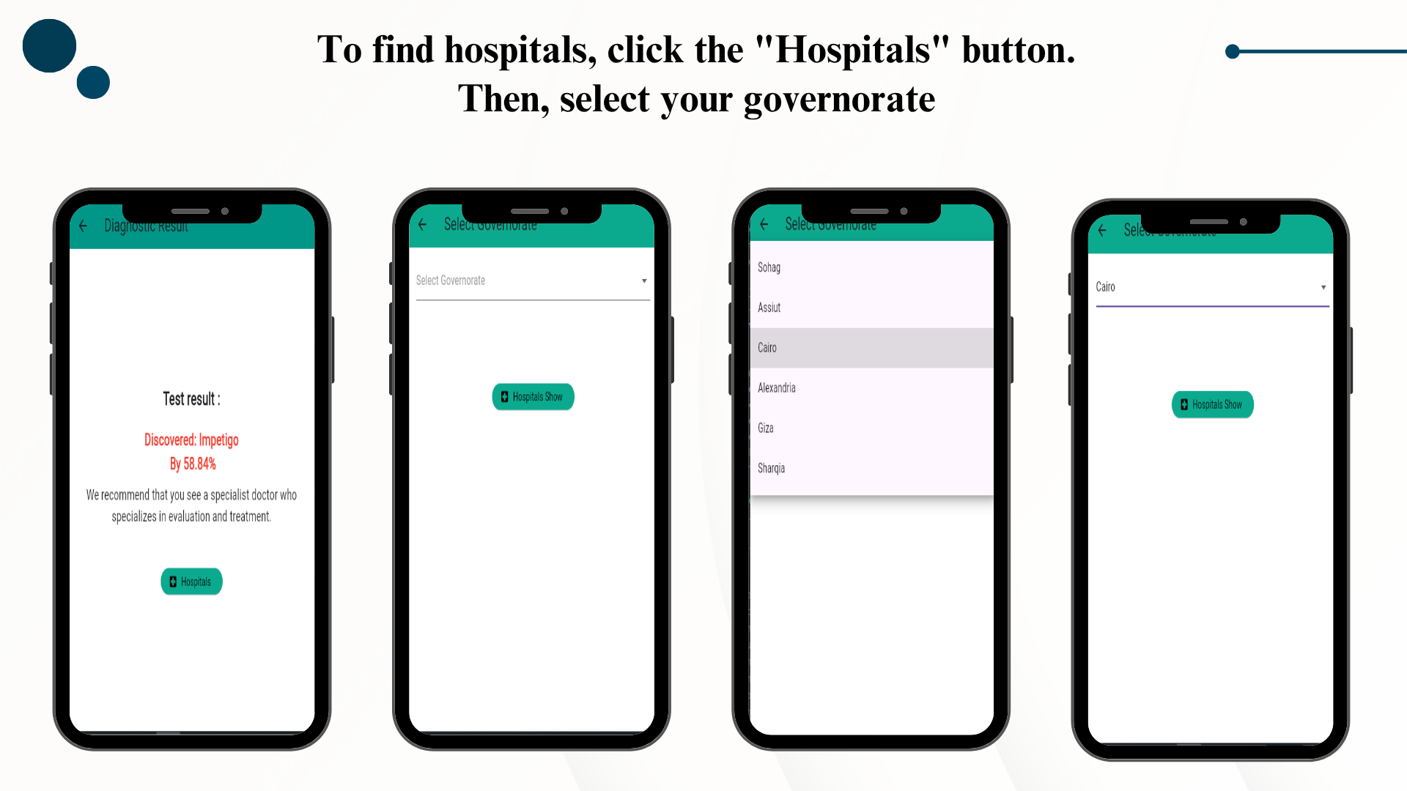

Figure 8.65 : Select Governorate Screen

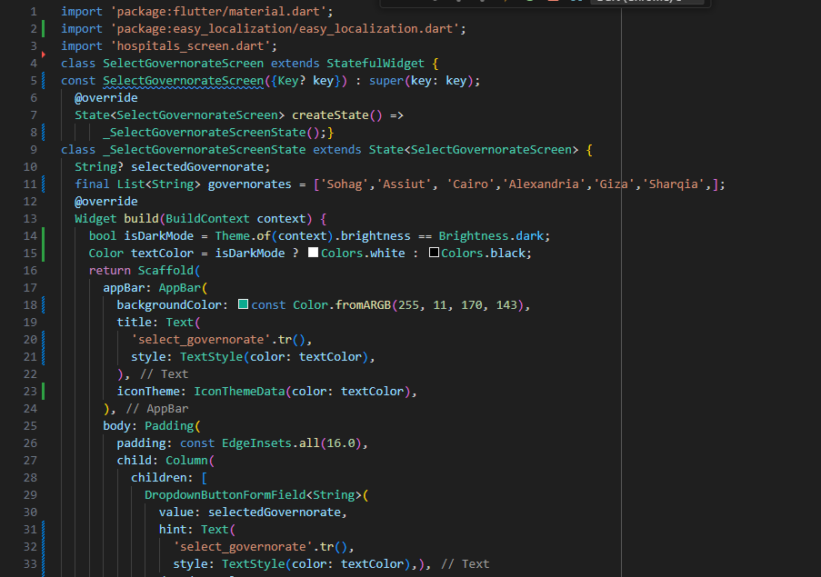

# Figure 8.65 : Code Select Governorate p1

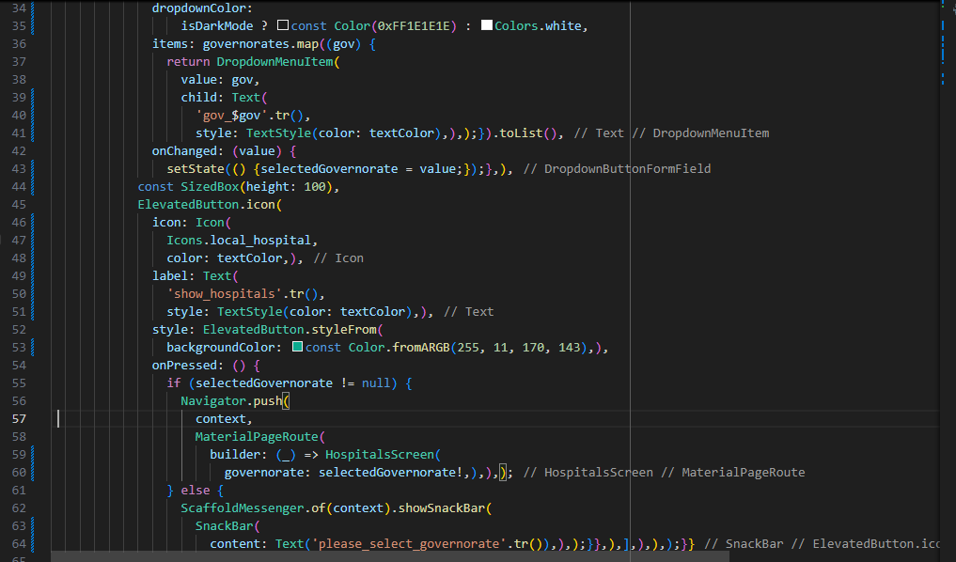 Figure 8.66 : Code Select Governorate p2

### **8.2.10 Hospitals Screen**

This page displays a list of hospitals based on the governorate selected by the user. It retrieves hospital data from Firebase Firestore and allows users to open each hospital's location on Google Maps.

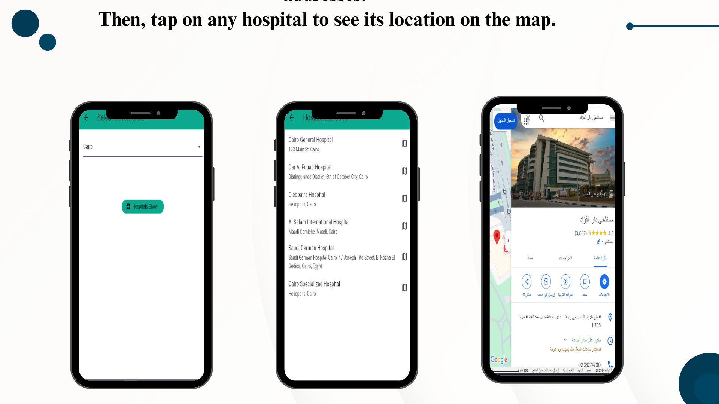

# Figure 8.67 : Hospitals Screen

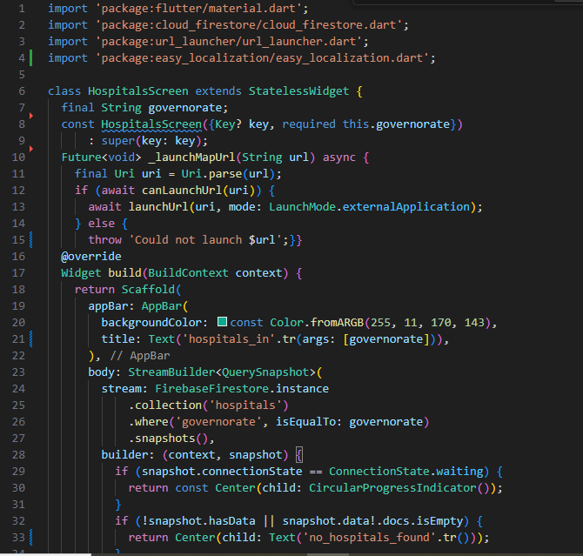

# Figure 8.67 : Code Hospitals Screen p1

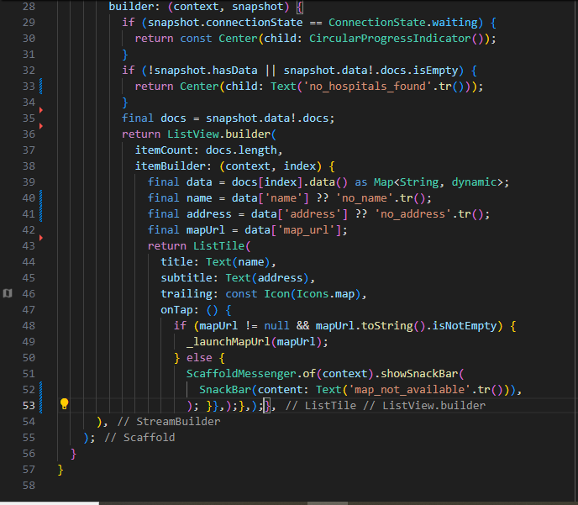Figure 8.68 : Code Hospitals Screen p2

### **8.2.11 Menu Drawer**

The Menu Drawer provides the user with easy navigation and settings, such as switching themes, changing language, viewing account information, and logging out.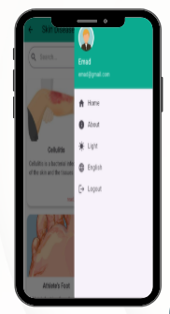

# Figure 8.69 : Menu Drawer

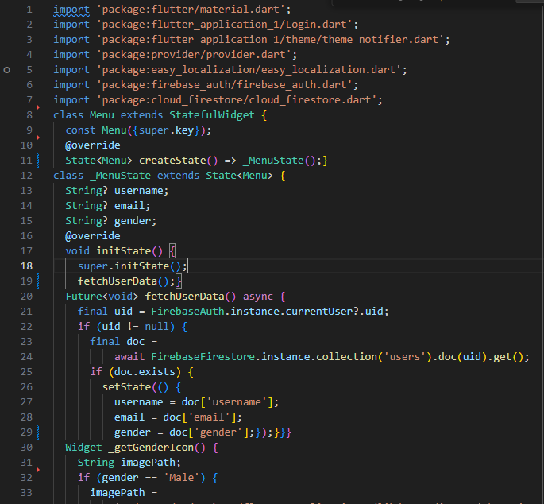 Figure 8.70 : Code Menu Drawer p1

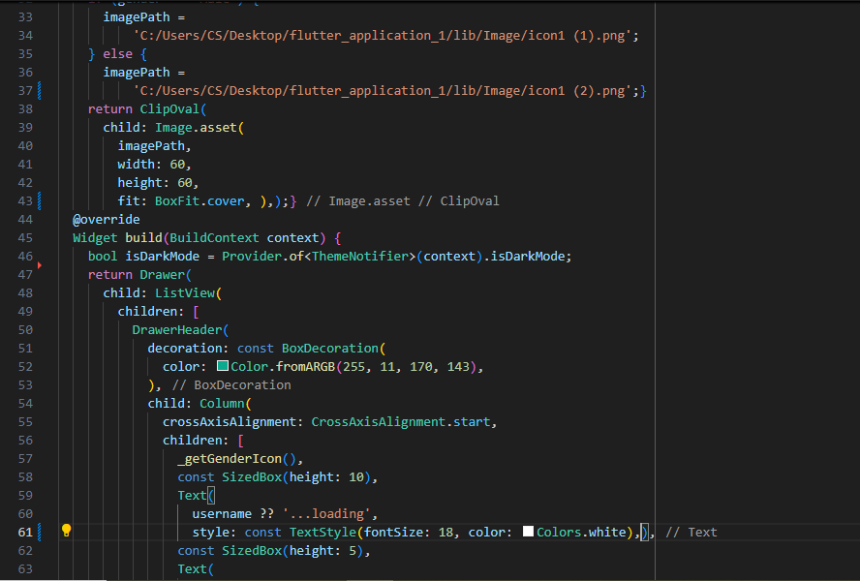

# Figure 8.71 : Code Menu Drawer p2

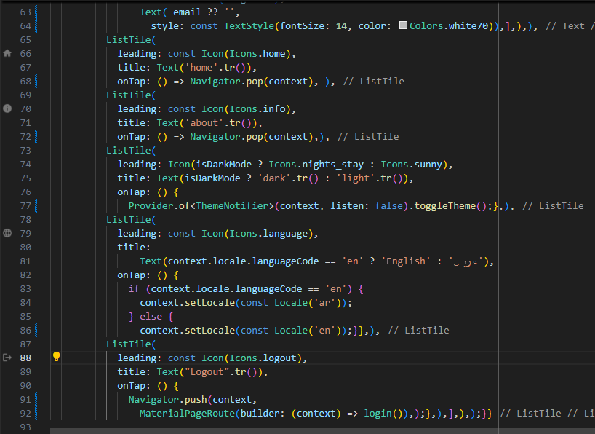Figure 8.72 : Code Menu Drawer p3

### **8.2.12 Translation Integration**

This Flutter application features a complete translation system that allows users to seamlessly switch between Arabic and English. Implemented using the easy_localization package, all UI elements — including buttons, menus, forms, and medical content — are dynamically translated based on the selected language.

Users can change the language at any time through the Menu Drawer, and their preference is stored locally using SharedPreferences to ensure it persists across sessions.

This multilingual capability enhances accessibility, supports a diverse user base, and contributes to a globally inclusive and user-friendly design.

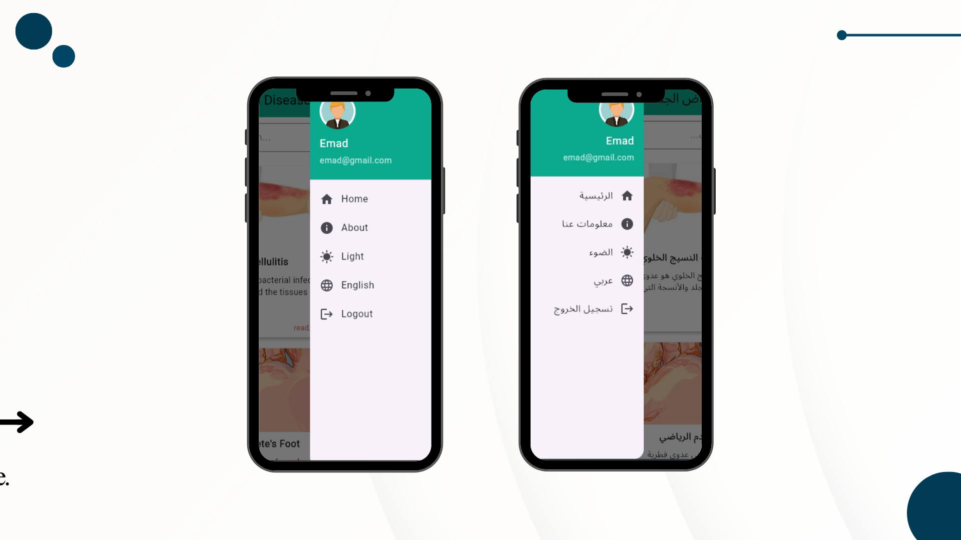

Figure 8.73 : Translation

Figure 8.74: Code Translation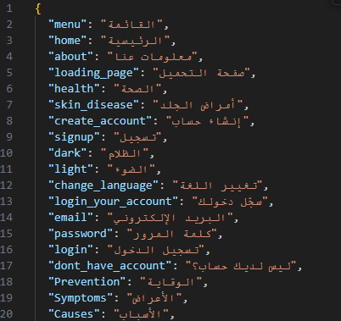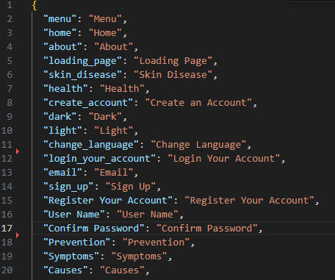

### **8.2.13 Theme Support**

This Flutter project offers complete support for both dark and light modes. The theming system is managed through a custom ThemeNotifier class in combination with the Provider package, allowing dynamic theme switching at runtime.  
Users can easily toggle between dark and light themes via the Menu Drawer, and their preference is saved locally using SharedPreferences, ensuring it persists across app sessions.  
This feature enhances accessibility, improves usability in different lighting conditions, and contributes to a modern, user-friendly design.

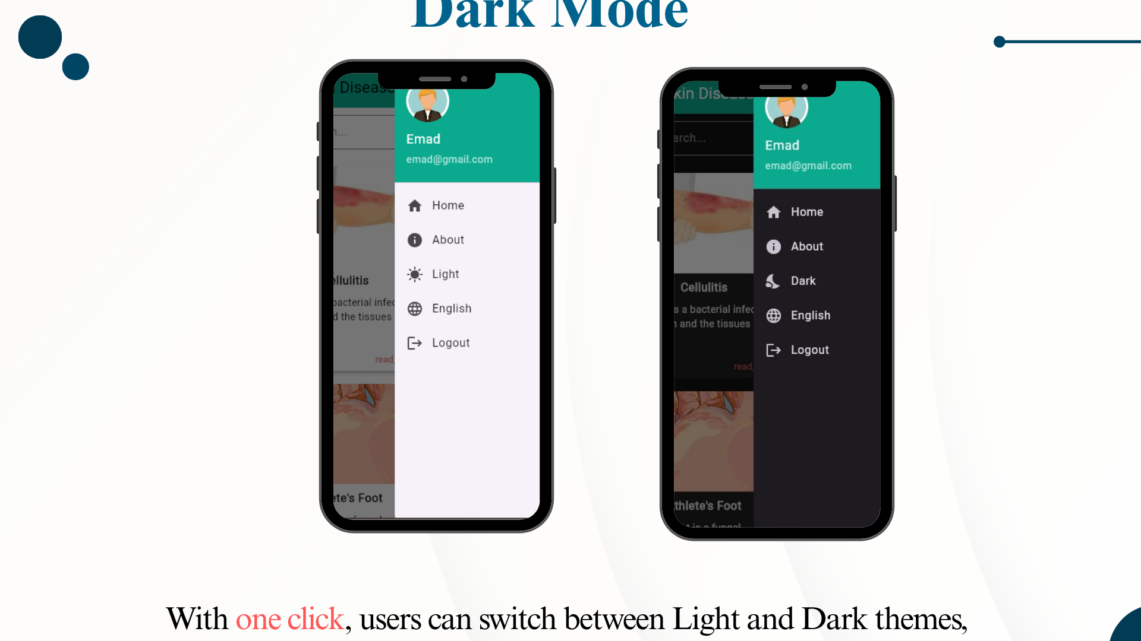

# Figure 8.75 : Theme Support

### **8.2.14 Flask Backend**

This project utilizes a Flask-based backend to handle image classification and diagnosis. When a user uploads an image through the Flutter application, it is sent to the Flask server via an HTTP POST request. The server processes the image using a pre-trained deep learning model (such as EfficientNetB0) to identify the most likely skin disease. The result, including the predicted condition and confidence score, is returned in JSON format to the Flutter app.

This integration between Flask and Flutter enables real-time, AI-powered diagnosis and ensures a smooth flow of data between the client and server, contributing to an efficient and responsive user experience.

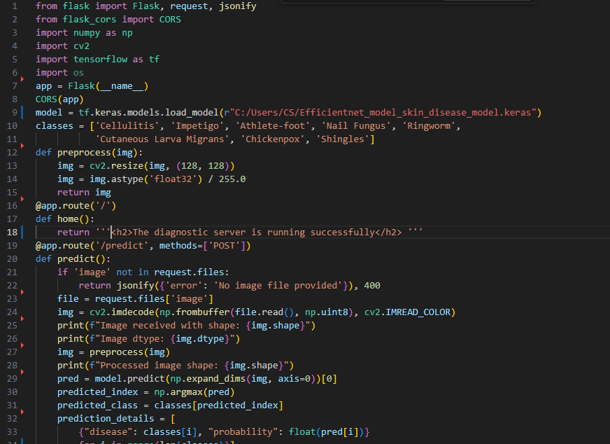

# Figure 8.76 : Code Flask p1

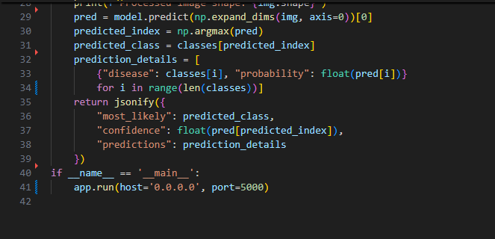

# Figure 8.77 : Code Flask p2

### 

### 

### **8.2.15 Firebase**

This project uses Firebase as the backend for both authentication and database management. User information — including username, email, and gender — is securely stored in a Firestore collection named "users". Upon login, the app retrieves the corresponding user data using the Firebase Authentication UID, and dynamically displays it in the Menu Drawer, including a gender-based profile icon.

Firebase Authentication also handles secure login and logout flows, ensuring proper session management. Additionally, hospital data is stored in Firebase, organized by governorate, allowing the app to efficiently query and display hospitals based on user location. Firebase’s seamless integration with Flutter ensures real-time data syncing and a responsive user experience.[19]

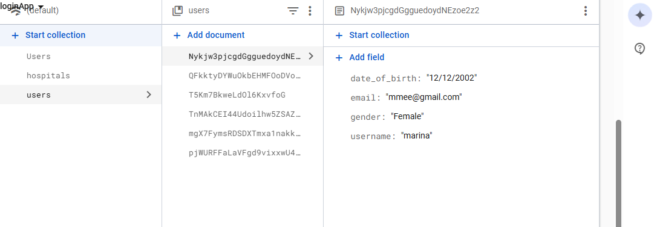

# Figure 8.78 : Firebase 1

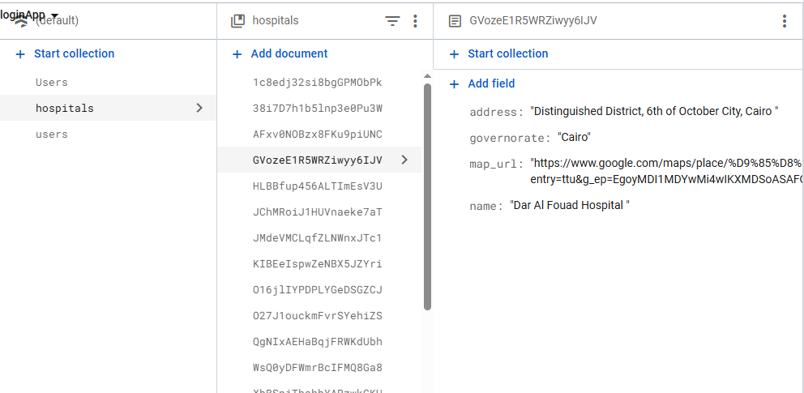

# Figure 8.79 : Firebase 2